MINISTRY OF SCIENCE AND HIGHER EDUCATION OF THE REPUBLIC OF KAZAKHSTAN

INTERNATIONAL INFORMATION TECHNOLOGY UNIVERSITY

DEPARTMENT OF CYBERSECURITY

Petrov A.I.
Muratbay M.A.
Kurbanbekov A.B.

AI model for Secure Decision-Making in Cyber Threat Detection Systems

DIPLOMA PROJECT

Educational program 6B06303 - Network Security

Almaty 2026

MINISTRY OF SCIENCE AND HIGHER EDUCATION OF THE REPUBLIC OF KAZAKHSTAN

INTERNATIONAL INFORMATION TECHNOLOGY UNIVERSITY

DEPARTMENT OF CYBERSECURITY

Approved
Head of Department,
Cand. of Tech. Sci.,
Assoc. Prof. Yeskendirova D.M.
«___» __________2026

DIPLOMA PROJECT

AI model for Secure Decision-Making in Cyber Threat Detection Systems

Educational program 6B06303 - Network Security

Done by: | Petrov A.I.  «___» _____2026 | ____________  (signature)
 | Muratbay M.A.  «___» _____2026 | _______________  (signature)
 | Kurbanbekov A.B.  «___» _____2026 | _______________  (signature)
Research advisor: | Dr. Nooritawati Md. Tahir.  «___» _____2026 | _______________  (signature)
Re | «___» _____2025 | _______________  (s)

Almaty 2026
International Information Technology University
Faculty of Computer Technology and Cybersecurity
Department of Cybersecurity
Educational program 6B06303 - Network Security

Diploma Project Assignment

Students
Petrov A.I., Muratbay M.A., Kurbanbekov A.B.

Diploma project topic
AI model for Secure Decision-Making in Cyber Threat Detection Systems

Approved by IITU order №___ dated «__»____2025

Diploma project submission date «__»____2026

Diploma project initial data
- Description of the topic and purpose of the project;
- Examples of cyber threat detection systems using artificial intelligence and machine learning;
- Research materials on existing web-based cyber threat detection and network monitoring systems.

Details of computations and explanations (list of issues due to be addressed)
- Analytical review of cyber threat detection systems and AI/ML methods for secure decision-making;
- Theoretical part: system architecture, attack surface, legal and ethical aspects;
- Practical implementation;

CD containing the digital version of diploma project and attachments

- Diploma paper documentation;
- Presentation of the diploma project;
- Electronic version of diploma project (the source code).

Consultations on Diploma Project (with related Project Chapters named)
Consultant | Name | Signature, date
 |  | Assignment given | Assignment received
Consultant on Economic Effectiveness of the Diploma Work/Project | Not Applicable
English language consultant | Dr. Nooritawati Md. Tahir
Compliance monitor | Dr. Nooritawati Md. Tahir

Date «__» ________2026

Research advisor | Dr. Nooritawati Md. Tahir «___» _____2026 | _______________  (signature)
Assignment received by | Petrov A.I.  «___» _____2026 | _______________  (signature)
 | Muratbay M.A.  «___» _____2026 | _______________  (signature)
 | Kurbanbekov A.B.  «___» _____2026 | _______________  (signature)

Diploma Project Writing Schedule

Petrov A.I., Muratbay M.A., Kurbanbekov A.B.

Title: AI model for Secure Decision-Making in Cyber Threat Detection Systems

№ | Assignment | Submission date
1. | Creation of the graduation project writing schedule | November 2025
2. | Collection, study, processing, analyzing, and generalizing data | November 2025 - December 2025
3. | Drafting and submission to the Research advisor (Introduction, Chapter 1, Chapter 2, Chapter 3, Conclusion) | January 2026 - February 2026
4. | Pre-defence | February 2026
5. | Revision of the graduation project with due consideration of the advisor’s comments | March 2026 - April 2026
6. | Submission of the completed diploma project to the Research advisor | April 2026
7. | Submission of the completed diploma project to the English language consultant | April 2026
8. | Submission of the diploma project to the compliance monitor | April 2026 - May 2026
9. | Submission of the diploma project for the plagiarism check-up | May 2026
10. | Submission to the reviewer for approval | May 2026
11. | Diploma project defense | May 2026 - June 2026

Student: Petrov A.I. _________________________
(signature)
Student: Muratbay M.A. _________________________
(signature)
Student: Kurbanbekov A.B. _________________________
(signature)
Research advisor: Dr. Nooritawati Md. Tahir _________________________
(signature)
Date «___» ______2026

АҢДАТПА

Бакалаврлық дипломдық жұмыс киберқауіптерді анықтау жүйелерінде шешім қабылдаудың қауіпсіздігін қамтамасыз етуге арналған бағдарламалық қамтамасыз етуді әзірлеуге бағытталған. Зерттеудің өзектілігі киберқауіпсіздік саласында жасанды интеллект технологияларының кеңінен қолданылуымен және машиналық оқыту алгоритмдеріне бағытталған шабуылдардың көбеюімен түсіндіріледі. Желілік трафикті бақылау және қауіпсіздік инциденттерін анықтау барған сайын автоматтандырылған жүйелерге жүктеліп отырған жағдайда, қабылданатын шешімдердің сенімділігін қамтамасыз ету аса маңызды міндет болып табылады.
Дипломдық жоба аясында желілік трафикті үздіксіз бақылауға және кіріктірілген жасанды интеллект моделінің көмегімен күмәнді белсенділікті талдауға арналған дербес компьютерге арналған бағдарламалық қосымша әзірленді. Ұсынылған жүйе ақпараттық қауіпсіздік мамандарына қолдау көрсетуге бағытталған және қауіптерді анықтау нәтижелерімен қатар, нейрондық желі қорытындыларының дұрыстығын бағалауға мүмкіндік беретін верификацияланған аналитикалық есептерді ұсынады. Бағдарламалық қамтамасыз етудің ерекшелігі - нейрондық желі шешімдерін қосымша тексеретін және состязательдік шабуылдар арқылы модельді алдау қаупін төмендететін қауіпсіз шешім қабылдау модулінің болуы.
Бағдарламалық кешен анықталған қауіптерді көрнекі түрде бейнелеуге арналған графикалық пайдаланушы интерфейсін, жедел хабарландыру жүйесін және шешімдердің интерпретациялануын қамтамасыз ететін модульді қамтиды. Эксперименттік тестілеу барысында қосымша үлкен көлемдегі деректерді өңдеу кезінде тұрақты жұмыс пен жоғары тиімділікті көрсетті. Алынған нәтижелер әзірленген жүйені корпоративтік желілерде киберқауіптерді анықтау процестерін автоматтандыру және ақпараттық қауіпсіздік саласында қабылданатын шешімдердің сенімділігін арттыру мақсатында қолдану мүмкіндігін растайды.

АННОТАЦИЯ

Дипломная работа посвящена разработке программного обеспечения, ориентированного на обеспечение защищённого принятия решений в системах обнаружения киберугроз. Актуальность исследования обусловлена активным внедрением технологий искусственного интеллекта в сферу кибербезопасности и одновременным ростом числа атак, направленных на уязвимости алгоритмов машинного обучения. В условиях, когда автоматизированные системы всё чаще используются для анализа сетевого трафика и выявления инцидентов, особое значение приобретает задача проверки надёжности и достоверности принимаемых системой решений.
В рамках дипломного проекта разработано десктопное программное приложение, предназначенное для мониторинга сетевого трафика и анализа подозрительной активности с использованием встроенной модели искусственного интеллекта. Разработанная система ориентирована на поддержку специалистов по информационной безопасности и предоставляет не только результаты обнаружения угроз, но и верифицированные аналитические отчёты, позволяющие оценить обоснованность выводов модели. Ключевой особенностью программного обеспечения является наличие модуля защищённого принятия решений, который выполняет дополнительную проверку выводов нейронной сети и снижает риск её искажения в результате состязательных атак.
Программный комплекс включает графический пользовательский интерфейс для наглядной визуализации обнаруженных угроз, систему уведомлений для оперативного оповещения о потенциальных инцидентах, а также модуль интерпретируемости решений, повышающий прозрачность работы интеллектуальной модели. В ходе экспериментального тестирования разработанное приложение продемонстрировало стабильную работу и высокую эффективность при обработке значительных объёмов данных. Полученные результаты подтверждают возможность практического применения системы в корпоративных сетях с целью автоматизации процессов обнаружения киберугроз и повышения надёжности принимаемых решений в области информационной безопасности.

ABSTRACT

The bachelor’s diploma thesis is devoted to the development of software aimed at secure decision-making in cyber threat detection systems. The relevance of the research is determined by the increasing use of artificial intelligence technologies in cybersecurity and the growing number of attacks targeting vulnerabilities of machine learning models. As automated systems are increasingly responsible for monitoring network traffic and identifying security incidents, ensuring the reliability and trustworthiness of AI-based decisions becomes a critical task.
Within the scope of the project, a desktop software application has been developed to perform continuous monitoring of network traffic and to analyze suspicious activity using an embedded artificial intelligence model. The proposed system is designed to support information security specialists by providing not only threat detection results, but also verified analytical reports that allow assessment of the reliability of the model’s conclusions. A distinctive feature of the developed software is the presence of a secure decision-making module, which performs additional validation of neural network outputs and reduces the risk of model deception through adversarial attacks.
The software suite includes a graphical user interface for visualizing detected threats, a notification system for timely alerting, and a decision interpretability module that improves transparency of the analysis process. During experimental testing, the application demonstrated stable performance and high efficiency when processing large volumes of data. The obtained results confirm the possibility of deploying the developed solution in corporate networks to automate cyber threat detection processes and to improve the reliability of decision-making in the field of information security.

CONTENTS

CONTENTS
LIST OF TERMS AND ABBREVIATIONS
INTRODUCTION
1 ANALYTICAL PART
1.1 Relevance of the Project
1.1.1 Growth of cyber threats and AI usage
1.1.2 Problems of reliable decision-making in cybersecurity
1.1.3 Current State of ML-Enabled IDS and Practical Analogues
1.2 Description of Existing Methods
1.2.1 Signature-based detection methods
1.2.2 Anomaly-based detection methods
1.2.3 Machine learning-based detection methods
1.3 Comparative Analysis of Existing Methods
1.4 Description of the Proposed Method
1.4.1 Method Overview
1.4.2 Input Stream and Event Representation
1.4.3 Feature Vector Construction
1.4.5 Defensive Decision-Making Layer
1.4.6 Decision Status Semantics
1.4.7 Operator-Facing Presentation and Reporting
1.5 Project Goal and Problem Statement
2 THEORETICAL PART
2.1 Algorithm of Functioning of the Proposed Method
2.2 Diagram of System Use Cases
2.3 Class Diagram (Data Model)
2.4 Sequence Diagram
2.5 Architecture of the System
2.5.1 Data Acquisition and Routing Layer
2.5.2 Core Processing and Verification Layer (Backend)
2.5.3 Presentation and Application Layer (Frontend)
3 TECHNICAL IMPLEMENTATION
3.1 Application Development
3.2 Software Implementation and Code Structure
3.3 User Interface Development
3.3.1 Main interface components
3.3.2 CSV Batch Import and Batch Results
3.3.3 Real-Time Monitoring Interface
3.4 Implementation of the Generation and Verification Algorithm
3.4.1 Stage 1: Random Forest Detector
3.4.2 Stage 2: Secure Decision Verification Layer
3.4.3 Decision Status Assignment
3.5 Database and API Implementation
3.6 Experimental Testing and Results
CONCLUSION
REFERENCES
APPENDIX
INTRODUCTION
Under the conditions of rapid development of digital technologies and continuous growth of processed information, concerns about effective control and prevention of unauthorized intrusions are increasing every day. Modern information systems operating in distributed network environments are exposed to various cyber threats, including complex and automated attacks. In this context, there is a growing need for intelligent threat detection tools and decision support or automated decision-making mechanisms in information security systems.
Intrusion detection systems have become an essential component of network security. In recent years machine learning and artificial intelligence methods have been actively applied in such systems, as they significantly improve the accuracy of detecting anomalies and previously unknown attacks. However, the use of AI-based models introduces a number of challenges related to their vulnerability to adversarial attacks, in which a potential attacker deliberately manipulates input data to influence the model’s outputs and distort detection results.
An analysis of the current state of research shows that many existing AI-based intrusion detection systems prioritize achieving high classification accuracy while the stability of the model and the security of the decision-making process itself remain insufficiently addressed. In such cases, there is a risk of incorrect or unsafe decisions under adversarial conditions, which significantly reduces the overall effectiveness of cybersecurity systems. Therefore, ensuring not only high detection accuracy but also the reliability and security of AI-based decision-making becomes a critical requirement for modern intrusion detection systems.
This diploma project is devoted to the development and implementation of an artificial intelligence model for secure decision-making in cyber threat detection systems that is resilient to adversarial attacks. Unlike conventional AI-based detection approaches, the proposed solution focuses on validating and stabilizing model decisions rather than relying solely on raw classification results. To achieve this goal the work includes an analysis of existing cyber threat detection methods, a study of adversarial attacks on machine learning models, the design of a secure AI model architecture, the implementation of a software prototype, and an evaluation of the effectiveness and stability of the proposed solution.
The object of the research is cyber threat detection systems.
The subject of the research is machine learning methods and secure decision-making approaches used in intrusion detection systems.
The theoretical significance of this work lies in the analysis and comprehensive consideration of approaches to improving the stability of AI models within cybersecurity tasks. The practical significance is determined by the potential application of the developed model to increase the reliability of threat detection systems in real-world operating environments. This approach allows the system to be used as a decision support tool for security analysts rather than an opaque fully automated solution.

ANALYTICAL PART

  - Relevance of the Project

    - Growth of cyber threats and AI usage

Cybersecurity is a critical component of the operation of contemporary information systems and digital networks. Banks, government bodies, industrial corporations and corporate networks are highly reliant on automated information technologies for data processing, process management and logical interaction of the system components. The increasing amount of information collected and transmitted, the growth in the number of devices connected to the network, and the growing use of network services result in a growing complexity of information system architectures. This, in turn, has an impact on the need for early detection and prevention of threats. Under these circumstances, the quality of models for threat detection is among the key factors that influence the sustainability of digital environment.
New research reveals that the creation of distributed digital environments is often accompanied by the use of automated data processing and decision-making systems based on artificial intelligence. These systems involve constant information exchange, multi-level network interactions and event processing in real time, which extends the functionality of systems and raises the potential targets for cyber attacks [1]. Modern cyber attacks not only affect individual technical elements but also logical control and decision-making systems, with attempts to influence the results of automated data analysis systems. This results in an increased threat of "stealthy" attacks, where system functionality can be altered without indications of system compromise, which reduces the effectiveness of conventional security approaches in highly automated and interconnected systems.

    - Problems of reliable decision-making in cybersecurity

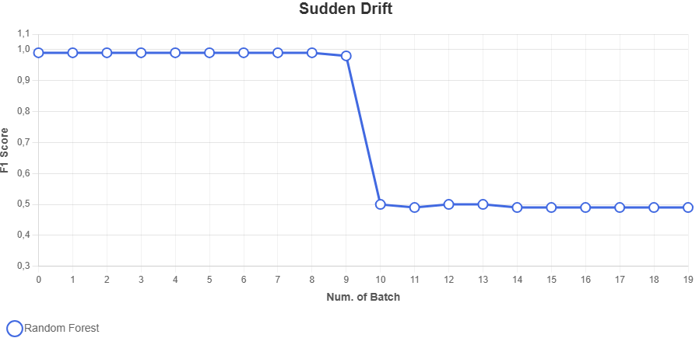
On the other hand, intrusion detection is now conducted in open and dynamic environments, where the statistical nature of network traffic is non-stationary due to system and software upgrades, new applications, changes in user experience and new types of attacks. This results in concept drift and feature drift, which can result in a gradual decline in the accuracy of machine learning and deep learning-based detectors if they are deployed under the assumption that the system is static. Theoretical works highlight that drift awareness and adaptability are emerging as critical requirements for intrusion detection systems and current approaches are isolated and not yet proven to be robust for deployment. The effects of concept drift are shown in the literature: a baseline intrusion detection model has a high F1-score for the first phase (or concept) of network traffic but experiences a significant drop in performance after the drift (Figure 1). This shows the F1-score over batches for a Random Forest baseline for a streaming scenario using the CIC-IDS2017 dataset. This suggests that laboratory performance may not translate to real-world reliability. Here, AI-based detection can be complemented with verification-based decision-making that assesses model confidence and consistency and mitigates the risk of incorrect automated decisions under dynamic traffic patterns [3].

Figure 1 - IDS performance under sudden concept drift (adapted from Costa et al. [2])

Apart from natural drift in the data distribution, the performance of AI-based intrusion detection can also be compromised by hostile attacks. Studies on adversarial machine learning for network intrusion detection demonstrate that adversaries might manipulate test data (evasion) or training data and update streams (poisoning) to cause systematic classification errors. These attacks undermine the reliability of automated security monitoring systems and suggest that merely achieving high classification accuracy is not enough for practical operation. This insight justifies the inclusion of a secure decision-making layer that not only delivers a class label but also enables plausibility checks, detection of doubtful cases, and risk-aware referral for human analysts in cases of contradictory, uncertain, and suspicious evidence [4].
In practice, intrusion detection systems should not only identify attacks but also provide high quality alerts to avoid overwhelming security operations. Survey findings indicate that conventional intrusion detection frequently suffers from a high volume of false-positive alerts and needs substantial human effort to check the validity of alerts, which could be time-consuming to detect a real incident and undermine trust in automated monitoring systems. In such circumstances, verification-oriented decision-making rules, such as alert verification, alert consistency analysis and prioritisation rules, can supplement the main AI model and enhance the actionability and trustworthiness of the model outputs for security experts [5].
In current circumstances, the issue of robust and secure decision-making in cyber threat management systems is still pertinent. The manipulation or distortion of outputs from automated models can result in delayed anomaly detection, an incorrect selection of response, and a serious impact on security. Further challenges are related to attacks on machine learning models aimed at deliberately influencing the outcomes of cyber threat analysis [3]. This drives the need for the development of special techniques for decision authenticity and trustworthiness in AI-based cyber security systems. Thus, the creation of software systems for secure decision-making in cyber threat detection systems is an important practical domain for bachelor's degree projects.

1.1.3 Current State of AI-Enabled IDS and Practical Analogues

The growing trend in cyber threat detection is towards a layered security architecture, where traditional IDS/IPS signature matching approaches are augmented with data-driven detection and operational insights. This practice is motivated by the variety of network-based services, volume of telemetry, and need to detect anomalies that are not explicitly defined by signatures. In this paradigm, AI-powered intrusion detection systems tend to be viewed as tools to support real-time monitoring and triage by learning from past events and providing confidence scores for detections. [10]
In practice, the most common inputs to IDS pipelines are structured representations of network traffic, typically not the payloads themselves. These typically include flow-based metrics (e.g., bytes and packets, duration, inter-arrival time, rates), protocol fields and flags, and windowed aggregation features that capture short-term behaviours. Further, many IDS deployments integrate network data with other security data sources like computer logs, authentication logs, and endpoint logs to provide evidentiary overlap for alerts. ML-based IDS surveys highlight that this feature-focused formulation is essential for scalability and for model performance assessment. [3]
As for modeling techniques, the state of the art includes supervised and unsupervised learning. Supervised approaches are often implemented using tree ensembles (such as Random Forest and gradient boosting) owing to their average performance and ability to deal with a wide range of features, whereas deep learning models are used when complex non-linear relationships or temporal dependencies are required. Unsupervised and semi-supervised methods (e.g., autoencoders and isolation-based approaches) continue to play a role when very few labels are available or when the goal is to identify anomaly from a model of normalcy. The literature also suggests that the evaluation has transitioned from using accuracy alone to more meaningful security metrics that consider false positives (e.g., Precision/Recall, F1-score, ROC-AUC or PR-AUC, and detection performance at low false positive rates). [10]
Intrusion detection datasets are widely used for reproducible research and benchmarking purposes. CIC-IDS2017 is a popular enterprise-like benchmark with several attack scenarios and UNSW-NB15 is a multi-class intrusion dataset for new-generation NIDS. These datasets enable comparative studies; yet, the literature also acknowledges limitations, including a distribution mismatch with real-world networks, unbalanced classes, and lack of coverage of encrypted or dynamic traffic patterns, leading to potential pitfalls in transferring results from the lab to the real world.
Following research trends, harmonised datasets - such as CIC-IDS2017 and the CIC-UNSW-NB15 (Augmented) dataset - are often used to assess the detection performance of models with similar feature representations. Standardized flow-based features allow for reproducible experiments and comparisons between studies without relying on inspection of the payload [11][12].
The threat model in current IDS research typically considers an external or internal adversary with the capability to create attacks that result in malicious network traffic such as network-level denial-of-service attacks, port scanning, credential guesswork, botnet command and control, and multi-step and multi-vector network intrusions. The objects of protection include enterprise networks, servers, services reachable via the cloud, and critical network zones where confidentiality, integrity and availability requirements must be maintained. In these scenarios, statistical reliability of automated detection becomes a security concern. [4]
Besides natural distribution changes in network traffic over time, recent research highlights two major issues for ML-based IDS: drift and adversarial attack. Drift is the non-stationarity of network activity due to software patches, new software, and user behaviour changes, which will lead to the drift of the detector if deployed with static assumptions. Adversarial manipulation refers to evasion during inference, and poisoning during training or model updates, which can lead to systematic bias. The above considerations require approaches where model inferences are used as evidence, and can be integrated with verification-based decision-making, confidence calibration and monitoring to inform reliable operational decisions in long-term deployments.
Examples of practical counterparts to intrusion detection systems (IDS) include open-source signature-based IDS (e.g., Snort and Suricata) and enterprise next-generation network detection and response (NDR) products that combine behavioral analytics and machine learning (ML) based triage. In Kazakhstan and the CIS region, deployments often involve a mix of international IDS/SIEM technologies and regionally deployed security products; though, there are few peer-reviewed technical papers that describe the internals of Kazakhstan-specific IDS. As a result, the analytical focus in this thesis is on architectures and techniques reported in international research literature, whereas the regional products are referred to as examples of signature-based deployments. Table 1 lists typical IDS/NDR solutions and their data sources, detection strategy and operating modes.

Table 1 - Examples of IDS/NDR solutions and typical characteristics

System / Region | Category | Typical analyzed data | Typical models / logic | Verification / drift notes
Kontinent SOV/SOA (Kazakhstan/CIS) | Commercial IDS/IPS / UTM | network traffic + rule events | signature/rule logic (deterministic) | rule validation; drift usually not applicable
Zastava-IDS (CIS) | Commercial NIDS | TCP/IP traffic patterns | signature/rule matching | rule validation; drift usually not applicable
Snort | OSS IDS | packets + protocol decoding | signature/rule engine | deterministic alerts; no ML drift logic by default
Suricata | OSS IDS/IPS | packets/flows + protocol metadata | signature/rule engine (extensible) | deterministic alerts; no ML drift logic by default
Cisco Secure Network Analytics / Stealthwatch | Commercial NDR | NetFlow/telemetry + behavior metadata | behavior analytics + ML-assisted detection | confidence/scoring; lifecycle handled vendor-side
Darktrace | Commercial NDR | network telemetry + behavior signals | unsupervised behavior modelling | anomaly scoring; vendor-managed adaptation
Vectra AI | Commercial NDR | network + cloud telemetry | ML-based detection + prioritization scores | scoring/triage; vendor-managed updates

The main analogue intrusion detection systems are described in Table 1. But not all of these systems have equal evidence support. As a result, the analysis will consider both solutions that are well-documented and open to direct evidence-based comparison and solutions that only allow for category-wise observations. Specifically, Table 2 shows the evidence-based comparison of Snort and Suricata, the most well-documented open-source signature-based intrusion detection systems (IDSs) [6]-[8].
Snort and Suricata are by far the most comparable systems among the analogues listed above for direct comparison because their system architectures, rule processing algorithms, and performance are investigated in multiple peer-reviewed publications [6]-[8]. Both solutions use a signature-based detection system, which means their alarms are relatively transparent and can be verified in SOC processes. On the same note, the literature notes the implementation differences, particularly in terms of scalability and traffic processing speed [6], [7].
Table 2 - Evidence-based comparison of Snort and Suricata

Criterion | Snort | Suricata
Detection paradigm | Signature-based rule matching | Signature-based rule matching
Rule transparency | Human-readable rules; alerts linked to explicit signatures | Human-readable rules; alerts linked to explicit signatures
Packet inspection | Deep packet inspection with rule-based matching | Deep packet inspection with rule-based matching
Architecture | Simpler packet-processing model | Multi-threaded architecture
Throughput/performance | Effective baseline, but more constrained under high-speed traffic | Better scalability under high-throughput conditions
Maintainability | Mature rulesets, but requires continuous updates and tuning | Similar dependence on rule maintenance; added architectural complexity
Detection scope | Strong for known and codified threats | Strong for known and codified threats
Novel threat handling | Limited by signature dependence | Limited by signature dependence
Explainability of alerts | High | High

As shown in Table 2, Snort and Suricata share the same rule-based detection logic and comparable interpretability, since both generate alerts linked to explicit signatures [6], [8]. The principal distinction lies in architectural scalability: Suricata was designed to improve throughput in high-speed environments through multi-threaded processing, whereas Snort is more constrained under increasing traffic load [6], [7]. This difference is operationally important in environments where traffic volume may exceed the practical processing limits of simpler inspection pipelines.
The two systems are also similar in terms of rule transparency and operational maintainability. Both use human-readable rule sets and support explicit signature-based event generation, which makes their alerts comparatively easy to review and validate in SOC workflows [6], [8]. At the same time, both depend on continuous rule updates and configuration tuning, since detection effectiveness is closely tied to the quality, relevance, and timeliness of deployed signatures [7], [8]. Their ability to detect previously unseen threats remains limited by design, because signature-based systems are optimized for known or formally describable attack patterns rather than behavioral novelty [6]-[8].
A further shared limitation concerns cases in which relevant malicious patterns cannot be directly matched in observable traffic content. Under such conditions, signature-based systems should be treated as strong and explainable baselines for known-threat detection, but not as complete standalone solutions for operational decision-making under uncertainty [6], [7]. For the purposes of this diploma project, Snort and Suricata therefore serve as the most appropriate evidence-based analogue baselines: they demonstrate how deterministic, rule-driven detection can provide transparent alerts that are easier to verify and interpret than outputs produced by opaque anomaly-oriented systems.
The remaining analogue systems are retained in the analytical overview, but they are not included in the detailed evidence-based comparison. Cisco Secure Network Analytics (Stealthwatch) is discussed only as a representative of flow-based detection systems, which are generally described in the literature as scalable approaches for analyzing aggregated traffic metadata in large and partially encrypted environments [9]. Such systems can broaden network visibility, but they also inherit the limitations of flow-level analysis, including reduced payload visibility and dependence on coverage quality [9].
Darktrace and Vectra AI are discussed only as representatives of commercial anomaly-oriented or UEBA-style systems. In the reviewed academic literature, such systems are typically associated with behavioral modelling, deviation detection, and support for identifying patterns that are not captured by static signatures [9]. At the same time, anomaly-based approaches are also associated with lower interpretability, false-positive burden, and stronger dependence on analyst validation when alerts are escalated for operational response [9].
Kontinent SOV/SOA and Zastava-IDS remain in the overview as regional analogue examples. However, because sufficient independent peer-reviewed academic validation was not identified for these systems, they are not subjected to detailed comparative analysis in this subsection.
From the standpoint of the proposed diploma system, the reviewed analogue solutions illustrate an important distinction between detection capability and decision reliability. Signature-based systems such as Snort and Suricata provide transparent and verifiable alerts, but remain limited by known-pattern coverage. Flow-based and anomaly-oriented approaches broaden observational scope, yet often introduce greater uncertainty and lower interpretability in operational settings. Therefore, the proposed secure decision-making model should not rely solely on detector output, but should supplement it with additional verification logic, structured alert interpretation, and decision-support mechanisms for handling uncertain or incomplete evidence.

  - Description of Existing Methods

1.2.1 Signature-based detection methods

Modern cyber threat detection employs a broad range of approaches that differ in assumptions, required data, computational cost, and operational objectives. For structured analysis, these approaches are commonly grouped into signature-based, anomaly-based, and machine learning-based detection methods.
In operational intrusion detection, the analyzed data may be represented at different levels, including raw packets, aggregated flow records, and security logs or telemetry streams. Packet-level analysis provides protocol and payload visibility but often imposes high computational cost and may be limited by encryption, while flow records summarize communication behavior through compact statistics such as counts, duration, and rates. Telemetry and logs (e.g., authentication and endpoint events) can further enrich context, but they are typically heterogeneous and require correlation logic. In this thesis, the analytical focus is placed on structured events derived from flow records, because this representation is scalable for continuous monitoring and supports consistent feature alignment across datasets. Accordingly, the subsequent review and the proposed method assume flow-level features as the primary input for detection and verification.
Signature-based detection is one of the earliest approaches to cyber threat detection and, despite the emergence of newer techniques, it still remains widely used in practice. Many antivirus products and network security tools rely on it because the underlying logic is direct: the system checks incoming traffic or system events against a maintained set of signatures that represent known malicious activity. These signatures are typically derived from previously investigated incidents and may take the form of byte patterns, protocol-specific indicators, or other recurring features associated with particular malware families and attack techniques.
Its continued popularity is largely explained by the fact that it performs very well when the threat has already been identified. Survey research points out that signature-based methods can deliver high detection accuracy with fast processing for known attacks, since the task is essentially deterministic pattern matching rather than complex inference [13]. This characteristic also supports interpretability in operational environments: it is often possible to trace an alert back to the exact signature that triggered it, which is helpful for analysts who need clear and predictable outputs. Another advantage is the relatively low computational cost. This becomes especially important in resource-constrained deployments, where heavy analytics may not be feasible. For instance, IoT-oriented studies show that lightweight signature matching can be an effective way to protect devices from common and well-documented threats without requiring model training or large-scale data processing [14].
At the same time, the main weakness of signature-based detection is not about implementation details but about its dependence on prior knowledge. A signature-based system can only recognize threats that have already been described and added to its database. As a result, it struggles with zero-day exploits and with modified variants designed to evade matching, including obfuscation and automated mutation of malicious code. Maintaining full and timely signature coverage becomes increasingly difficult in a threat landscape where attackers can rapidly generate new variants, which directly reduces the protection provided by purely signature-based defenses [13].
For this reason, signature-based detection is best described as a method that is highly effective against known threats. Its practical value is directly related to the completeness and timely maintenance of the signature database, which determines how well the system can cover current attack variants [16]. In environments where the threat landscape changes rapidly, these limitations often motivate the use of additional detection mechanisms that operate beyond strict signature matching. For that reason, it is useful to consider anomaly-based detection next, where suspicious activity is identified through deviations from expected behavior rather than predefined patterns.

1.2.2 Anomaly-based detection methods

Anomaly-based detection methods are built on a simple but important assumption: malicious activity often reveals itself not by a known “signature,” but by behaving differently from what is typical for a given system. Instead of searching for patterns already recorded in a database, anomaly-based approaches try to describe what normal operation looks like in a network and then monitor for deviations. When an observed event noticeably falls outside this expected behavior, it is treated as suspicious. This change in perspective is valuable because it allows security monitoring to move beyond only “known threats” and respond to activity that has not been previously documented.
In practical terms, anomaly-based detection requires a baseline profile of normal behavior. Depending on the context, this baseline can be formed using statistical properties of traffic flows, timing characteristics of events, or recurring behavioral patterns of users and applications. Once such a reference is established, the system compares current observations against it and raises an alert when deviations exceed an acceptable range. Because the detector is not tied to predefined attack descriptions, it can identify intrusion attempts that do not match any existing signature, including zero-day exploits and newly emerging attack strategies [12].
This adaptability is one of the main reasons anomaly-based methods are often described as a useful complement to traditional signature-based security tools. Modern infrastructures rarely remain stable: services are updated, workloads change, and user activity can vary significantly over time. In environments like these, rigid detection rules may become outdated quickly, whereas anomaly-based systems, at least in principle, can react to shifts in behavior and highlight patterns that deserve attention. Systematic studies emphasize that this property makes anomaly-based detection particularly relevant in complex and rapidly changing settings, where it is unrealistic to assume that all threats can be enumerated in advance [12].
At the same time, the same flexibility that makes anomaly detection attractive also creates operational difficulties. The most common problem is the increased likelihood of false-positive alerts. In real networks, unusual does not necessarily mean malicious: rare but legitimate actions-such as irregular administrative activity or short-term workload spikes-may appear suspicious and trigger alerts. Empirical work shows that this issue becomes more visible in practical deployments, where “normal” behavior is diverse, context-dependent, and not always predictable [16]. When false-positive alerts accumulate, analysts may waste time on low-value investigations, and the overall credibility of automated detection may deteriorate.
Another limitation concerns the stability of the baseline itself. Anomaly-based systems depend heavily on the quality and representativeness of the data used to define normal behavior. If the baseline is built from incomplete or biased observations, detection performance becomes unreliable. Moreover, the learning phase can become an indirect target: attackers may attempt to influence the environment in ways that shift the baseline, making harmful actions blend into what the system later treats as normal [16]. These factors make it difficult to sustain consistent anomaly-based detection in environments where behavior evolves continuously and where the boundary between normal variation and genuine intrusion is not clearly defined.
Anomaly detection enhances monitoring by enabling the identification of events that deviate from known signatures. At the same time, during practical implementation, persistent issues often arise, such as false-positive alerts and baseline instability. These limitations explain why many IDS projects use data-driven approaches that allow for more complex decision boundaries based on observations. In the next subsection, detection methods based on machine learning are considered as a separate category of approaches.

1.2.3 Machine learning-based detection methods

Detection methods based on machine learning are widely studied in intrusion detection research as an approach that learns decision boundaries from data and can be applied alongside methods based on signatures and anomalies. Instead of relying on a fixed set of rules or manually supported underlying data, machine learning models learn prediction patterns directly from data. When trained on large volumes of network traffic and system events, these models create predictive mechanisms that classify actions as benign or malicious based on relationships between observed features.
As part of intrusion detection, machine learning is most often applied using classification and clustering procedures that use features extracted from network traffic, protocol headers, and system logs. Supervised learning is based on labeled datasets and is designed to separate normal traffic from attack-related activity, while unsupervised and semi-supervised settings are aimed at identifying hidden structures or unusual groupings without requiring complete labeling. Review studies emphasize that this flexibility allows an ML-based intrusion detection system to identify complex attack behaviors that cannot be reliably addressed by static signatures or simple anomaly thresholds, especially when threats develop faster than rule sets can be updated [10].
The practical power of machine learning-based detection lies in its ability to model nonlinear dependencies and operate in high-dimensional feature spaces. This is important because many modern attacks are not visible with a single indicator; they manifest themselves as sequences of small events that look benign individually, but become suspicious in combination. As attackers increasingly use evasive and adaptive behavior tactics, the ability of ML models to generalize based on historical observations becomes an important advantage for automated analysis. For this reason, machine learning is often used in IDS pipelines, where the volume and variety of events make careful manual control difficult.
At the same time, the adoption of machine learning introduces new difficulties that are directly connected to decision reliability. Many effective models, particularly those based on complex architectures, behave like black boxes and provide limited insight into why a specific prediction was produced. In operational settings, this creates a real problem: security analysts must decide whether an alert reflects a genuine incident or a model artifact, and a system that cannot justify its outputs often struggles to gain sustained trust. Recent work explicitly points out that insufficient transparency can reduce trustworthiness in ML-based IDS solutions and slow down their practical adoption in security operations [17].
Another limitation relates to data dependency and stability over time. Model performance depends on whether the training data remain representative of the environment where the system is deployed. In real networks, behavior changes: services are updated, user activity shifts, and attacker techniques evolve. Under these conditions, concept drift, class imbalance, and deliberate manipulation of inputs can gradually degrade detection accuracy and lead to unstable decisions, increasing both false-positive alerts and false negatives [3],[4]. This is not a minor technical detail, because inconsistent decision-making in a security context can translate into wasted analyst time or missed attacks.
For this reason, current research increasingly treats accuracy as only one part of the evaluation problem. Evidence from systematic reviews indicates that ML-based anomaly detection studies report performance using multiple complementary metrics, reflecting the operational importance of both missed attacks and alert overload (Figure 2) [15]. In particular, measures such as true positive rate (TPR/recall), false positive rate (FPR), precision, F1-score, and AUC are frequently used to characterize IDS performance beyond a single aggregated accuracy value.
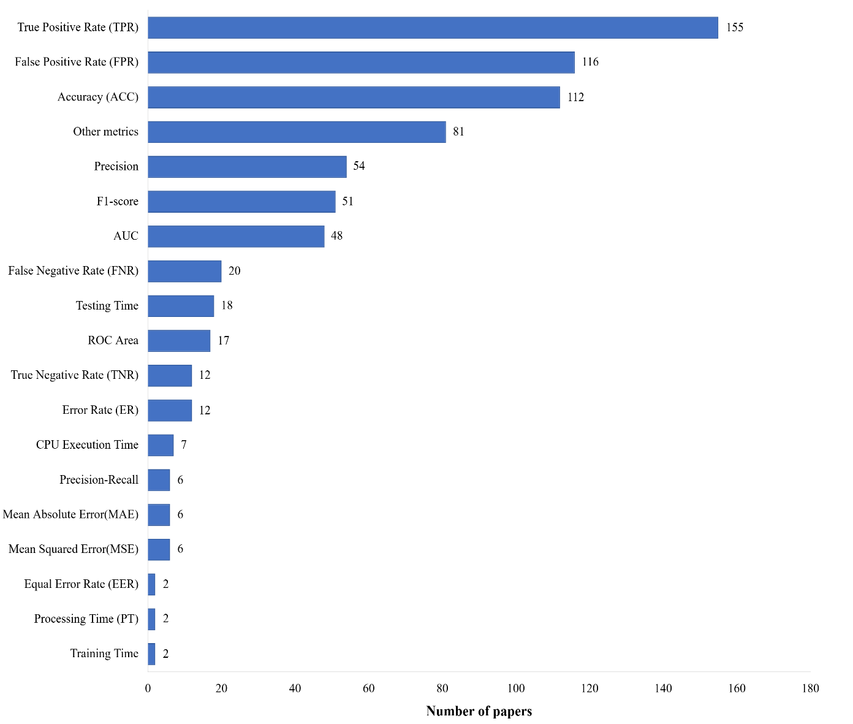
Figure 2 - Frequency of performance metrics reported in ML-based anomaly detection studies (adapted from Nassif et al. [15]).

This emphasis on multi-metric evaluation indicates that high accuracy alone does not guarantee operational reliability. In this context, ML-based detection pipelines can be complemented by additional decision logic that supports verification of suspicious cases, prioritization of alerts, and analyst-oriented validation, which is directly related to the secure decision-making approach developed in this project.
Attention is shifting toward methods that strengthen the transparency and robustness of decision-making, including approaches based on explainable artificial intelligence that provide interpretable reasoning for model outputs and help analysts validate alerts in context [17]. These trends indicate that interpretability and reliability are increasingly being considered as practical requirements rather than additional features in ML-based intrusion detection [12]. In the context of this project, this is directly related to the question of how automated outputs can be validated and maintained before they are used in operational decision-making.
For reproducible and methodologically consistent evaluation, this study relies on two publicly available intrusion detection benchmarks: CIC-IDS2017 and the CIC-UNSW-NB15 (Augmented) dataset. Both datasets provide labeled network traffic scenarios representing multiple attack categories in enterprise-like environments.
To ensure comparability across datasets, a unified flow-based feature schema is adopted. The analytical representation is limited to structured flow-level attributes rather than raw packet payloads. The shared feature space includes: (i) flow statistics such as packet counts, byte counts, duration, and traffic rates; (ii) protocol indicators and flags derived from transport-level behavior; and (iii) aggregated window-based characteristics reflecting short-term traffic dynamics.
Feature alignment is achieved through consistent categorical encoding of protocol-related fields, normalization of numerical attributes to comparable scales, and systematic handling of missing or dataset-specific fields by excluding non-overlapping attributes from the unified schema. This alignment strategy ensures that models are trained and evaluated on semantically equivalent representations across datasets.
By restricting the analysis to harmonized flow features, the study supports scalable deployment, avoids reliance on packet payload inspection, and enables controlled cross-dataset comparison of detection and verification performance. Such schema consistency strengthens the methodological validity of model training, threshold calibration, and verification experiments.
In current IDS research and practice, ML-based detection is commonly implemented using a small number of model families that provide strong baselines across heterogeneous flow features. For supervised learning, tree ensembles such as Random Forest and gradient boosting decision trees (GBDT) are frequently used due to their robustness, competitive performance on tabular network features, and relatively stable training behavior. Deep learning architectures (e.g., multilayer perceptrons and sequence-aware models) are often considered as an option when higher-capacity representations are required to capture complex nonlinear patterns or temporal dependencies. In parallel, unsupervised and semi-supervised anomaly detection remains relevant when labeling is incomplete or when the objective is to detect deviations from learned normal behavior; typical choices include autoencoder-based models and isolation-based methods such as Isolation Forest. In this thesis, these families are treated as baseline and candidate approaches for the detection component, enabling systematic comparison under a unified feature schema and evaluation criteria suitable for operational IDS deployment.

1.3 Comparative Analysis of Existing Methods

In order to identify the most suitable approach for secure decision-making in cyber threat detection, it is necessary to compare the existing methods across key criteria. Table 2 provides a qualitative comparison of signature-based, anomaly-based, and machine learning-based detection techniques. The criteria considered include detection capability for zero-day (previously unseen) threats, accuracy on known attacks, adaptability to evolving threats, decision interpretability, computational resource requirements, and stability under adversarial conditions. By evaluating each method against these dimensions, we can discern their respective strengths and limitations in the context of building a reliable and secure detection system.

Table 2 - Comparative Analysis Table of Operational Characteristics
Feature | Signature-based | Anomaly-based | ML-based
Zero-Day Detection | Low | High | Medium
Accuracy on Known Attacks | High | Medium | High
Adaptability to New Treats | Low | High | High
Decision Interpretability | High | Medium | Low/ black-box
Resourse Requirements | Low | Medium | High
Stability under Adversarial Attacks | Low | Medium | Low

As shown in Table 2, each approach excels in certain aspects while underperforming in others. Signature-based detection offers very high accuracy on known attacks and alerts are highly interpretable - security analysts can easily trace a detection to a specific signature or rule. It is also computationally efficient, requiring minimal resources for pattern matching. However, this method is heavily reliant on prior knowledge. It provides low adaptability and poor zero-day threat coverage: novel attack variants or obfuscated malware that do not match existing signatures can evade detection entirely. This fundamental limitation means a signature-based system cannot reliably handle emerging threats. Moreover, a clever adversary can readily bypass signature defenses by making slight modifications to known exploits, highlighting the method’s limited resilience.
Anomaly-based detection addresses the coverage gap by flagging deviations from normal behavior, thereby offering high potential to catch zero-day attacks and generally better adaptability to new threats. Unlike signature systems, an anomaly-based monitor does not need a predefined pattern to recognize malicious activity - it can theoretically detect any sufficiently abnormal event. In practice, this strength comes with trade-offs. Anomaly detection tends to have moderate accuracy on known attacks (since it might catch them, but not as precisely targeted as signature matching) and often suffers from false positives. Legitimate but unusual behavior can be misclassified as malicious, partly due to the lower interpretability of anomaly alerts. When an alert is raised simply because something “looks unusual,” it may be unclear which factors triggered the alarm, complicating the analyst’s decision-making. The method’s ongoing learning or baseline model also incurs moderate resource demands. While not as computationally heavy as training complex ML models, maintaining and updating a baseline of normal activity (and possibly retraining it as systems evolve) requires a non-trivial amount of data processing. Overall, anomaly-based systems expand detection coverage to unknown threats and changing conditions, but they struggle with decision consistency and clarity - an aspect crucial for secure decision-making.
Machine learning-based detection can be seen as an attempt to combine the strengths of both prior approaches while handling greater data complexity. Well-trained ML models achieve high accuracy on known attack classes, often rivaling signature methods in recognizing previously seen threats. At the same time, they can generalize from data, giving them medium effectiveness on zero-day or evolving threats - in some cases detecting attack patterns that were not explicitly pre-programmed. ML-based systems are also adept at analyzing high-dimensional data and subtle patterns, meaning they can identify complex or stealthy attack behaviors that might elude simpler rule-based or threshold-based systems. This adaptability to nuanced patterns represents a notable advantage of AI methods. However, these benefits come with significant challenges. Advanced ML models (especially deep learning) typically require high computational resources for training and operation, which can be a barrier in resource-constrained environments. More importantly, their decision processes are usually opaque, giving low interpretability. A classification result from a neural network, for example, does not readily explain why a network connection was flagged as malicious. This lack of transparency can undermine trust in the system’s decisions a critical issue when the goal is secure and reliable decision-making. Additionally, as noted earlier, ML-driven detectors inherit vulnerabilities from their learning algorithms, including sensitivity to shifting data patterns and deliberate manipulation. Without special precautions, they may produce inconsistent alerts if the characteristics of traffic evolve or if an attacker feeds inputs crafted to confuse the model.
One of the most demanding criteria for modern intrusion detection is how well each method withstands adversarial interference. In a cybersecurity context, adversaries may intentionally modify their attack strategies to exploit weaknesses in the detection mechanism - for example, altering malware to evade signatures, subtly shaping traffic to appear normal, or crafting inputs to mislead an ML classifier. Figure 3 - Detection Accuracy under Adversarial Pressure illustrates the relative impact of such adversarial tactics on the detection accuracy of the three approaches. 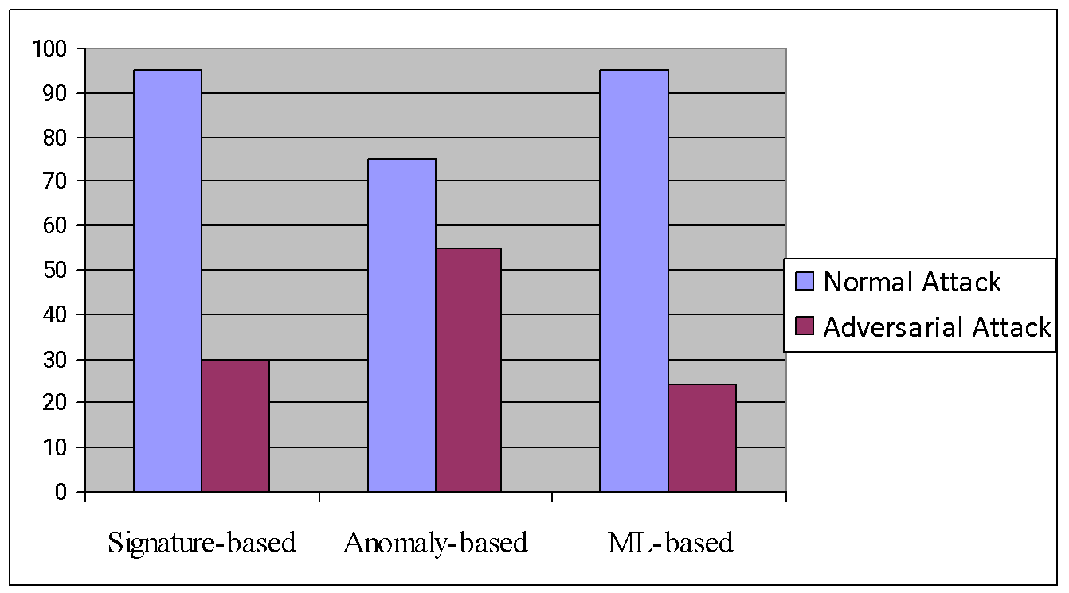
Figure 3 - Detection Accuracy under Adversarial Pressure

Under adversarial conditions, detection effectiveness degrades for all three methods, but to vastly different extents. Signature-based detection, which relies on exact matches to known patterns, suffers a severe drop in accuracy when attackers employ evasion techniques. As shown in Figure 3[18], a signature system that performs nearly flawlessly on ordinary (uninformed) attacks may detect only a small fraction of cleverly modified intrusions. Anomaly-based detection is somewhat more resilient: because it looks for unusual behavior in general, an attacker must work harder to “blend in” with normal patterns. The figure indicates that anomaly-based methods experience a moderate decline in accuracy under adversarial pressure - a smaller drop compared to the signature and ML approaches. Nonetheless, if an attacker gradually poisons the baseline model or carefully mimics legitimate behavior, the anomaly detector’s performance can degrade. The ML-based approach shows the most pronounced vulnerability. In Figure 3, the machine learning detector initially matches the signature method in baseline accuracy, but under adversarial manipulation its accuracy plunges dramatically. Small, intelligently crafted perturbations to inputs (for instance, adversarial network packets or logs) can cause an ML model to misclassify what would normally be obvious attacks. This pronounced drop in ML accuracy under hostile input demonstrates a critical concern: conventional ML models, while powerful, can be tricked into unsafe decisions without robust safeguards. In summary, the comparative trend highlights that anomaly-based detection maintains relatively better performance under adversarial strain than the other two methods, whereas signature and standard ML models are especially susceptible to being fooled by adversarial tactics.
The comparative review demonstrates that the three major classes of detection methods solve different parts of the cyber threat detection problem, but none of them alone provides a consistently reliable basis for secure operational decisions. Signature-based systems offer fast and transparent recognition of known threats, yet their effectiveness is structurally limited by signature coverage and rapidly decreases when attackers modify patterns. Anomaly-based detection expands coverage towards previously unseen behaviors, but its practical value is constrained by baseline instability and the tendency to generate ambiguous alerts that require additional human validation. Machine learning-based detection is capable of capturing complex patterns and achieving strong performance on representative data, however its decisions often remain difficult to interpret and may degrade under adversarial pressure, as reflected by the accuracy reduction shown in Figure 3 [18]. As a result, high nominal detection capability does not automatically translate into decision trustworthiness in realistic adversarial environments, where attackers actively adapt to the monitoring logic.
These findings indicate that the key limitation is not only the choice of a detection algorithm, but the absence of a systematic mechanism that can validate and justify the detector’s output before it is used for response actions. In practice, security officers need more than a binary label; they require evidence, confidence, and the ability to identify situations in which the model’s conclusion may be unreliable due to evasion or adversarial influence. Therefore, the next step is to consider an approach that supplements detection with a dedicated decision verification layer. Next introduces the proposed method, which combines automated threat identification with secure decision verification mechanisms aimed at increasing robustness, interpretability, and overall trust in AI-driven cyber threat detection.

1.4 Description of the Proposed Method

1.4.1 Method Purpose and Core Idea

The proposed method defines a secure decision-making workflow for cyber threat detection in which automated model outputs are not treated as final operational decisions. The method combines AI-based detection with an explicit verification stage that assesses whether a detected threat is sufficiently credible to be escalated to a security operator. As a result, the system produces a structured decision status that reflects both the detection outcome and the verification result, enabling consistent alert handling, monitoring, and reporting.
The threat model assumed in this project considers an external or internal adversary capable of generating malicious network behaviors and attempting to influence automated detection outcomes. Typical attacker activities include volumetric denial-of-service traffic, reconnaissance and port scanning, credential brute-force attempts, botnet-style command-and-control communication, and multi-stage intrusion patterns; additionally, the adversary may employ evasion at inference time or data poisoning during model updates to induce misclassification. The protected objects are enterprise and cloud-connected network assets, including servers, endpoints, and critical network segments where availability, integrity, and confidentiality must be preserved. Under these assumptions, the method outputs an operator-oriented decision record for each observed event, consisting of a predicted label (threat class or benign), a confidence score, an explicit verification status, and supporting metadata required for interpretation and reporting (e.g., verification details and context fields).

1.4.2 Workflow Structure

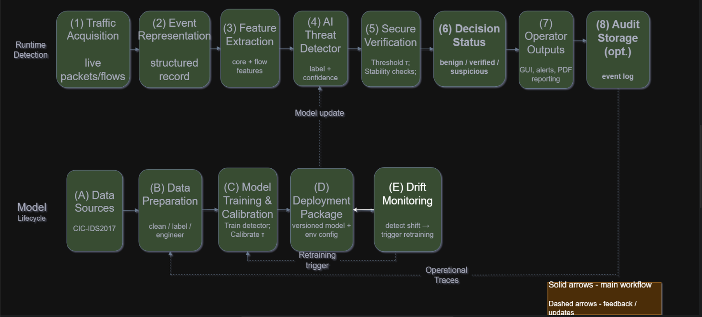
The proposed method is organized as an end-to-end workflow that combines a runtime detection pipeline with a supporting model lifecycle for long-term operation. In the runtime path, traffic observations are acquired and represented as structured events, transformed into a feature vector, processed by an AI detector that outputs a threat label with an associated confidence value, and then passed to a secure verification stage. The verification stage evaluates the credibility of the detector output before producing an operator-oriented decision status, which is subsequently used for visualization, alerting, and reporting. In parallel, the lifecycle path defines how the detection model is trained and maintained using established intrusion detection datasets (e.g., CIC-IDS2017) and, where available, operational traces, supporting data preparation, model training, threshold calibration, and versioned deployment. To preserve stable performance under evolving traffic conditions, drift monitoring is included as a dedicated mechanism that can trigger retraining or recalibration when degradation signals are observed. The overall workflow is illustrated in Figure 4.

Figure 4 - Workflow of the proposed secure decision-making method for cyber threat detection.

As shown in Figure 4, secure verification is positioned after the detector output and before alert escalation, ensuring that the operational decision is derived from both the predicted class and its assessed credibility. The lifecycle components complement this runtime flow by enabling controlled model updates and calibration adjustments, while drift monitoring provides a structured trigger for maintenance actions when traffic distributions change over time.

1.4.3 Traffic Observation and Feature Extraction

The pipeline starts with continuous observation of network activity. Raw traffic data, represented as packets or flow records, is converted into structured events suitable for analysis. A feature extraction module transforms low-level traffic observations into a compact feature representation that captures relevant statistical, protocol, and timing characteristics. This preprocessing stage provides a standardized input format for the detection model and ensures that subsequent analysis focuses on informative attributes rather than raw packet content. The feature representation adopted in this study follows a unified flow-based schema compatible with CIC-IDS2017 and CIC-UNSW-NB15 (Augmented). By focusing on structured flow statistics, protocol indicators, and window-level aggregates, the method maintains scalability and ensures alignment between training and operational data sources.
Accordingly, each observed traffic event is represented as a flow record-based structured input rather than raw packet payload. This choice supports scalable monitoring and maintains compatibility between training datasets and operational inputs used by the proposed detection and verification workflow.

1.4.4 AI-Based Detection Output

In the detection stage, an AI model evaluates extracted features to identify suspicious behavior and potential cyber-attacks. The detector produces an initial decision for each event, typically expressed as a predicted class (e.g., benign versus malicious or a threat category) and an associated confidence estimate. The confidence value is treated as an essential component of the decision process, because it supports verification, interpretability, and the prioritization of operator attention. At the implementation level, the detection component is realised as a Random Forest classifier (scikit-learn, 320 estimators, max_depth=18, balanced_subsample class weighting), trained on a canonical 77-feature flow schema. This choice was motivated by the algorithm's robustness to outliers in flow-level data, insensitivity to feature scaling, and low inference latency — a critical requirement for continuous stream monitoring. Gradient boosting and neural network architectures were considered as alternative candidates but were not included in the final implementation, as the Random Forest configuration achieved sufficient detection performance while satisfying the latency constraints of the proposed pipeline.

    - Defensive Decision-Making Layer
The proposed method includes not only an attacker-oriented threat model, but also an explicit defensive component implemented as a dedicated decision-making protection layer. This layer is positioned between the primary AI detector and the alert escalation component. Its purpose is not to replace the classifier, but to prevent unsafe operational actions when the model output is unstable, weakly supported, or inconsistent with the observed traffic context. From a cybersecurity perspective, the defensive layer serves as a barrier against adversarial evasion, drift-related degradation, and uncertain predictions that might otherwise be treated as confirmed incidents. As a result, the system does not rely solely on attack detection, but also validates whether the detected event should be considered operationally trustworthy.
The defensive layer applies several complementary validation mechanisms. First, confidence validation checks whether the predicted class probability exceeds an operational threshold calibrated during model validation. Second, context consistency validation compares the model output with surrounding evidence, including traffic statistics, protocol behavior, and short-term event correlation. Third, stability validation examines whether minor variations in feature values or neighboring observations lead to contradictory labels, which would indicate a fragile decision surface. Fourth, cross-evidence consistency assesses whether related observations support the same conclusion rather than contradict it. Finally, interpretability support provides a concise explanation of the factors that influenced the prediction, allowing an analyst to assess whether the decision is plausible.
The outcome of this stage is an explicit verification result that either confirms the credibility of the detected threat or marks the case as requiring cautious interpretation. Only events that satisfy the defensive criteria are escalated as verified threats; otherwise, the system assigns a cautious status such as suspicious or analyst review required. In operational terms, this layer controls escalation, reduces the likelihood that uncertain model outputs are treated as confirmed incidents, and transforms raw AI inference into a defended operational decision.

1.4.6 Decision Status Generation

After the verification stage, the method assigns a final decision status to each observed event. The decision status is not a raw binary output; it is an operational category that reflects both detection and verification. This mapping ensures that alerts are interpreted consistently and that the system communicates not only whether a threat was detected, but also whether that detection is considered sufficiently credible for immediate response.

To formalize the meaning of each decision status and its intended handling, the proposed method uses the semantics summarized in Table 3.

Table 3 - Decision Status Semantics

Decision status | Definition | Operational meaning | Recommended handling
Benign | No threat indicated by the detector | Traffic is considered normal for the current observation | Log for monitoring; no escalation
Verified Threat | Threat detected and verification criteria satisfied | The alert is considered credible and actionable | Escalate as a confirmed alert; prioritize response; include in reporting
Suspicious (Verification Failed) | Threat detected but verification criteria not satisfied | The model output is treated as uncertain or potentially manipulated | Flag for analyst review; retain verification details; monitor for corroboration

Table 3 specifies how the system translates analytical outputs into operator-facing categories. This status model enables controlled escalation: verified threats are treated as actionable, while suspicious cases are explicitly distinguished as requiring additional attention rather than being silently ignored or escalated indiscriminately.
The final output of the proposed method is an operator-oriented decision record generated for each observed traffic event. At the logical level, this record includes the predicted class label, confidence score, verification status, and supporting metadata required for interpretation and reporting. In the software implementation, JSON is used as the standard machine-readable output format, while report and batch export functions support both JSON and CSV representations. This separation allows the system to support both real-time API-based integration and operational reporting workflows.

1.4.7 Operator-Facing Outputs and Reporting

The proposed method is designed to provide outputs that support real-time monitoring and post-incident documentation. In a monitoring interface, the system presents the decision status together with supportive metadata such as the confidence score, predicted threat type, and verification notes. This information can be used to structure operator workflows, including alert triage and prioritization.
In addition to interactive monitoring, the method supports reporting as an operational artifact. A report aggregates detected threat events and attaches the corresponding confidence and verification outcomes, providing traceability of alerts and enabling review of security-relevant observations over a chosen time window. Such reporting is intended to support incident documentation and facilitate communication between analysts and stakeholders.

1.5 Project Goal and Problem Statement

The goal of this diploma’s project is to develop and evaluate an AI-enabled cyber threat detection method in which the output of an AI Threat Detector is validated by a Secure Decision Verification layer and expressed as an operator-oriented Decision Status for reliable continuous monitoring under evolving network traffic conditions.
To achieve this goal, the following objectives are formulated:
- Define the operational scope of the detection task, including the attacker model, protected assets, and the required method outputs for each event: threat_type, is_threat, ai_confidence, is_verified, and verification_details.
- Specify a unified event representation as flow record-based structured events and define a flow-based feature schema (flow statistics, protocol indicators, and window-based aggregates) suitable for continuous monitoring.
- Select baseline and candidate model families for the AI Threat Detector, including supervised learners (e.g., Random Forest / GBDT) and, where appropriate, unsupervised or semi-supervised anomaly detectors (e.g., autoencoders / Isolation Forest).
- Prepare training and evaluation data using CIC-IDS2017 and CIC-UNSW-NB15 (Augmented), and define feature alignment principles to ensure dataset compatibility (categorical encoding, normalization, and consistent handling of missing fields).
- Design the detection stage to output a predicted label (benign vs. threat or threat category) together with ai_confidence, enabling downstream verification and prioritization.
- Design the Secure Decision Verification layer and define verification criteria (e.g., confidence-based filtering, stability/consistency considerations, and context plausibility checks) that determine is_verified and produce verification_details.
- Define the Decision Status semantics and handling logic for operator-oriented triage, using the categories Benign / Verified Threat / Suspicious (Verification Failed).
- Specify operator-facing outputs for monitoring and documentation, including visualization requirements and reporting artifacts, and the minimum metadata required for traceable alerts and post-incident review.
- Define an evaluation plan and metrics appropriate for IDS deployment (e.g., Precision/Recall, F1-score, ROC-AUC or PR-AUC, and false positive rate constraints) and specify a lifecycle procedure for drift monitoring and controlled model update triggers.

THEORETICAL PART

2.1 Algorithm of Functioning of the Proposed Method

A suggested method of defensive approach to cyber threat detection is offered and executed as a three-phase, stepwise workflow on safe network traffic processing. During the first stage, network traffic is sampled and converted into traffic events out of a stream of raw observations. The second step converts generated traffic events into high dimensional feature vectors to be analyzed using machine learning. The third stage involves the primary classifier that works on the extracted information to come up with an initial prediction; this is a class assignment and a level of confidence.
On the fifth level, the reached decision is sent to a visualization and alerting subsystem where the operator is provided with a clear picture of the forecasted class and a supporting verification outcome. The final phase deals with storage - event record, decision status, and all other metadata are stored to be analyzed post-hoc, to report on compliance and monitor the model. This multi-step design does not allow the system to simply execute whatever the first classifier does. Any potentially malicious event is subjected to an extra validation stage prior to any form of escalation occurring, making the entire pipeline significantly more resilient to adversarial pressures and reducing the potential of unsafe automated actions.
The essence of the proposed system is to create a pipeline of detectors that are both secure and reliable and transparent enough that operators can trust them. Modern intrusion detection systems based on machine learning models can be remarkably effective, but are vulnerable to concept drift and are infamously susceptible to adversarial examples [15]. This is regularly used by attackers who add minor distortions to network traffic, biasing the model towards a false negative without causing an alarm. In response to this, the suggested solution no longer considers the classifier as an opaque black box but rather, provides an intermediate analytical element, the Secure Decision Verification Module, between raw prediction and operational response. Figure 5 presents the entire workflow.
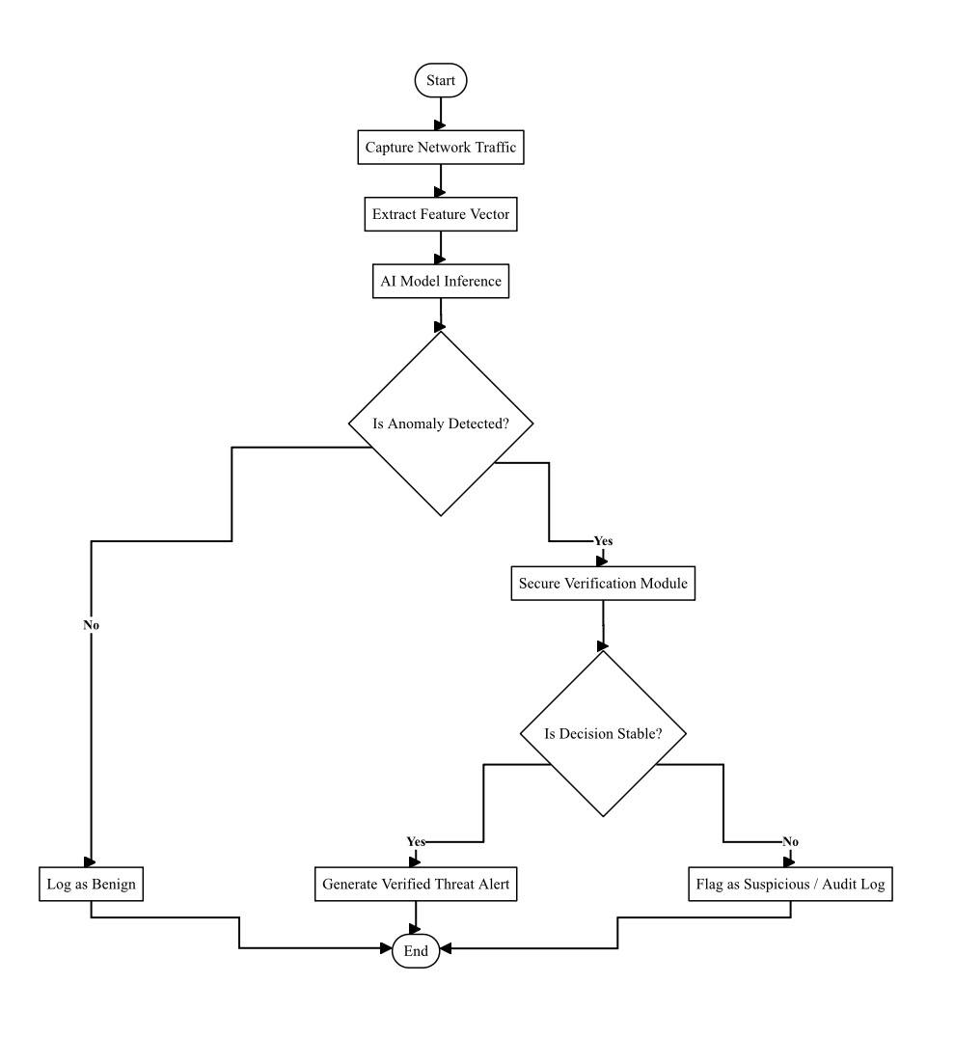
Figure 5 - Flowchart of the proposed secure decision-making algorithm

Figure 5 illustrates that the entire process begins with the system continually monitoring the network interface to detect traffic entering the system. Raw packets are captured and assembled into structured network flows, out of which a common feature vector is subsequently obtained-capturing duration of connection, the number of bytes transferred, frequency of particular protocol flags, etc. This compression of data to a form of a vector makes things mathematically manageable and does not add any visible processing latency.
After preparing the feature vector, it is forwarded into the main deep neural network. The model uses anomaly detection to address the classification problem, basically seeking outliers instead of corresponding known attack signatures [9]. It returns to you a predicted label indicating whether the traffic is benign or possibly dangerous, and a confidence score along with that call. The network itself was designed with a trade-off in mind.-.it is possible to maintain a high level of detection and still be able to perform inferences at the speed that can be afforded by a standard hardware.
The next thing that makes this algorithm special is its next step. On a sign of threat by the primary model, the system does not automatically provide the operator with an alert. Rather it waits and does a stability check of the prediction. Slight random perturbations are made on the initial feature vector, resulting in a batch of very slightly altered test inputs, all of which are subsequently pulled through the model. The concept is simple: a true threat must lead to a stable and consistent forecast despite a low input change. When the confidence score crashes when those little changes are introduced, that is an indicator that the initial decision might not be reliable-perhaps the output of an adversarial manipulation and not a genuine attack.
The ultimate label that each event gets is determined by the outcome of that verification. Apparently clean traffic is logged and passed benignly without interruption. In case the model successfully recognizes a threat and the stability check succeeds, the incident is escalated as confirmed threat and immediately critical alert is issued. However, when the model found something suspicious and the stability check failed, the event is placed in an intermediate category-flagged to a human analyst to review instead of being blocked automatically. This difference is important since doing too much in response to a wobbly forecast is precisely what you do to trigger a false denial-of-service, and it is precisely this level of collateral damage that this layer aims to prevent without compromising the security posture.

2.2 Diagram of System Use Cases

The use case diagram can be used as a blueprint of the functional requirements of the proposed cyber threat detection system. It diagrammatically depicts the system limits, the participating actors as well as the fundamental interactions that are necessary to support secure decision-making. When applied to the current-day cybersecurity context, the strict division of roles between automated machine learning elements and human operators is required to implement more complex analytical models. The ability to trace the provenance of automated decisions, and to maintain a very strict separation between the original anomaly detection process and the later mathematical verification of this process are important design aspects to consider in terms of ensuring overall system reliability and accountability [5]. Figure 6 visually illustrates the functional interactions and delimitations of the suggested solution.

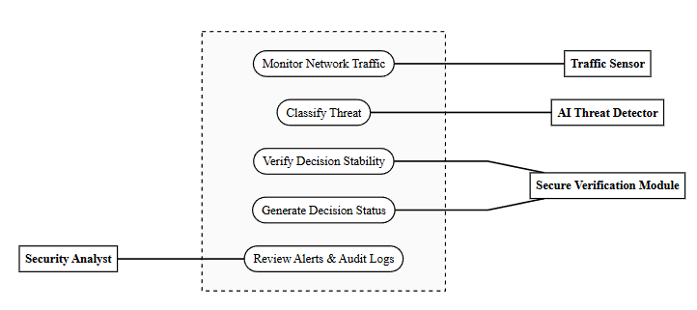
Figure 6 - Use case diagram of the secure decision-making system

As can be seen in Figure 6, the operational environment is made up of human and automated system actors. The main human contributor is the Security Analyst who will oversee the overall health of the network, reviewing alert escalations and carry out incident response procedures. To reduce the probability of alert fatigue and to ensure that the analyst is not flooded with unverified anomalies, the system architecture proposes three different automated actors: the Traffic Sensor, the AI Threat Detector and the Secure Verification Module.
The Traffic Sensor is a continuously running background process, which implements the use case of Monitor Network Traffic. It is charged with the responsibility of real time packet capture of network packets and the consequent extraction of standardized feature vectors. After the data is ready, the AI Threat Detector triggers the "Classify Threat" use case. This actor uses advanced techniques of deep learning to detect anomalies [15], which analyzes the feature vectors to determine possible deviations based on benign network behavior. It produces an initial threat tag and a score of confidence. Nonetheless, since machine learning models are vulnerable to adversarial inputs, this actor cannot raise an alarm with the Security Analyst.
Rather, the output is removed by the Secure Verification Module, which implements the "Verify Decision Stability" use case. This is the most vital interaction within the system. The verification module provides a systematic assessment of the strength of the AI Threat Detector in the output through the introduction of small perturbations to the input data and monitoring the stability of the confidence score. This verification process is isolated into a distinct automated role by the system, thus preventing evasion attacks and false positives naturally.
The generation of the Decision status use case starts when the Secure Verification Module is activated by a successful or unsuccessful stability check. In this process, the incident is classified as a Benign, Verified Threat or Suspicious. It is not until this categorization has been done that the system will involve the Security Analyst via the "Review Alerts & Audit Logs" use case. The analyst is given an extensive dashboard, which shows the individual alerts of the isolated alerts of the 'Verified Threats' in addition to the mathematical justification and the provenance of the decision [5]. Suspicious events, which do not pass the stability check, are recorded to be manually audited but not to automatically block a network, thus providing a balanced, secure and human in the loop workflow.

2.3 Class Diagram

The class diagram defines the static architecture of the proposed secure decision-making system. It illustrates the core system classes, their attributes, operational methods, and the structural relationships between them. Utilizing an object-oriented approach ensures that the system remains modular, allowing independent updates to the machine learning components and verification logic without altering the entire detection pipeline. Traditional signature-based systems often lack this architectural flexibility, making them less effective against dynamically evolving attacks [13].
The detailed structure of the data model and object relationships is presented in Figure 7.
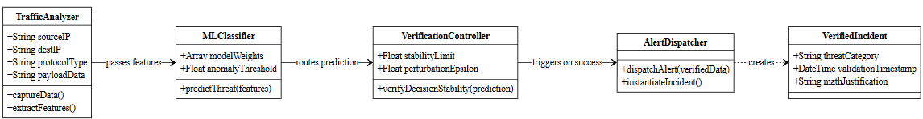

Figure 7 - Class diagram of the proposed threat detection system

As shown in Figure 7, the system comprises several interconnected operational classes. The TrafficAnalyzer class is responsible for ingesting raw network data. Its primary attributes include source IP address, destination IP address, protocol type, and payload data. This class utilizes internal methods such as captureData() and extractFeatures() to parse the network packets and prepare standardized numerical feature vectors for further analysis.
Once the features are extracted, the data is processed by the MLClassifier class. This class encapsulates the primary artificial intelligence model. It contains attributes related to the neural network architecture, such as model weights and anomaly thresholds. The main method of this class, predictThreat(), evaluates the input numerical vector and generates a preliminary threat label alongside a mathematical confidence score.
To enforce the secure decision-making protocol, the output of the MLClassifier is restricted from directly triggering system alerts. Instead, the preliminary data is routed to the VerificationController class. This class acts as the core of the proposed security mechanism. It holds attributes defining stability limits and perturbation parameters. It executes the verifyDecisionStability() method, which systematically tests the robustness of the AI prediction to ensure the confidence score remains stable under varying conditions.
If the verification criteria are satisfied, the verification module interacts with the AlertDispatcher class. The AlertDispatcher is responsible for instantiating a VerifiedIncident object. This final object contains the confirmed threat category, a validation timestamp, and the mathematical justification for the decision. The VerifiedIncident is then transmitted to the presentation layer, ensuring that the human security analyst only receives validated and highly credible threat notifications.

2.4 Sequence Diagram
The sequence diagram delineates the dynamic, temporal behavior of the proposed secure decision-making system. While the class diagram establishes the static structural foundation of the application, the sequence diagram maps the chronological flow of messages, method invocations, and data transfers between instantiated objects during a live threat detection event. Maintaining a strict, unalterable execution order ensures that the verification layer cannot be bypassed by adversarial inputs or system race conditions [12]. The system is specifically designed to handle asynchronous network streams while enforcing synchronous bottlenecks during the critical verification stage.
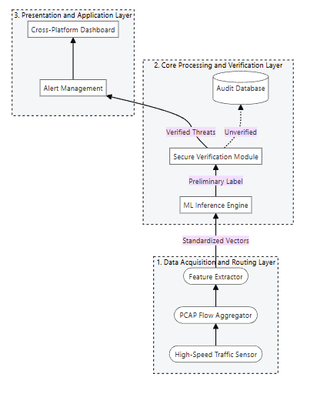
The complete chronological execution of the threat detection and verification processes is illustrated in Figure 8.

Figure 8 - Sequence diagram of the secure decision-making process

The operational sequence initiates at the system boundary when continuous network traffic reaches the monitoring interface. The TrafficAnalyzer object operates in a continuous loop, capturing incoming raw data packets asynchronously. To prevent memory overflow and ensure processing efficiency, this object buffers the packets until a complete network flow is successfully identified [9]. Once the flow is assembled, the TrafficAnalyzer executes its internal extractFeatures() method to compile a standardized numerical vector. Following this preparation, it dispatches a synchronous request, passing the extracted feature vector directly to the MLClassifier object for evaluation.
Upon receiving the feature vector, the MLClassifier activates its primary neural network algorithms by invoking the predictThreat() method. The machine learning model evaluates the numerical input against established anomaly patterns and learned baseline behaviors [15]. The method concludes by returning a preliminary response object that contains two vital pieces of information: the predicted threat label and a corresponding mathematical confidence score. Crucially, the architectural design dictates that the sequence does not proceed directly to the presentation layer at this stage, thereby preventing unverified, potentially manipulated AI outputs from triggering false alarms.
If the preliminary label generated by the MLClassifier indicates a potential anomaly, the sequence mandates an asynchronous call to the VerificationController. This object immediately intercepts the workflow and initiates the verifyDecisionStability() method. During this temporal bottleneck, the system systematically evaluates the robustness of the AI's confidence score against potential adversarial perturbations [18]. The sequence completely halts further escalation, placing the alert on standby until this mathematical verification yields a definitive boolean result.
The final resolution of the sequence depends entirely on the boolean value returned by the VerificationController. If the verification process returns a positive validation, confirming that the AI's decision is stable, the controller dispatches a synchronous execution message to the AlertDispatcher. The AlertDispatcher then immediately invokes the generateVerifiedIncident() method, compiling the data into a finalized alert package, which is subsequently pushed to the dashboard. Conversely, if the verification returns a negative result, indicating decision fragility, the sequence actively bypasses the AlertDispatcher. Instead, the VerificationController routes the data to a secure audit log with a "Suspicious" tag, terminating the sequence securely without overwhelming the human operator.

2.5 Architecture of the System

The architectural framework of the proposed secure decision-making system is designed following a multi-layered (n-tier) approach. This design paradigm ensures the strict decoupling of data acquisition, machine learning inference, mathematical verification, and user presentation. By isolating these core functionalities into distinct architectural layers, the system achieves high modularity, allowing independent component updates without disrupting the overall threat detection pipeline. The architecture is optimized for edge computing environments, eliminating the prerequisite for expensive, enterprise-grade server clusters.
The architecture is structurally divided into three primary operational layers, as illustrated in Figure 9.
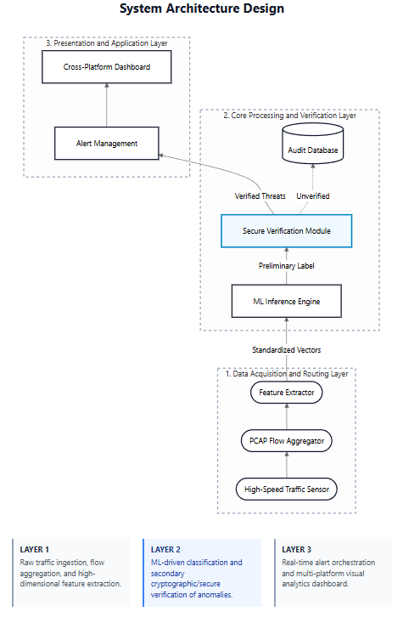
Figure 9 - Multi-layered architecture of the proposed system

2.5.1 Data Acquisition and Routing Layer

The foundational layer is responsible for the continuous ingestion of network traffic. It is designed to interface seamlessly with modern high-throughput networking hardware, efficiently processing high-speed streams from standard consumer and prosumer routers (such as devices operating on the AX3000 standard) without experiencing packet loss or memory overflow [7]. This layer captures raw PCAP data, aggregates it into network flows, and performs the initial dimensionality reduction to generate standardized numerical feature vectors.

2.5.2 Core Processing and Verification Layer (Backend)

This layer constitutes the analytical engine of the system and encapsulates both the artificial intelligence components and the mathematical verification logic. The machine learning pipeline is highly optimized for performance, utilizing advanced deep learning methods for anomaly detection [10]. Instead of relying on cloud-based processing, which introduces unacceptable latency and potential data privacy risks, the inference engine is designed to run locally. The computational load is balanced to ensure zero-latency execution on accessible, consumer-grade workstations and laptops (e.g., standard Legion 5 hardware specifications, utilizing mid-range CPUs and discrete GPUs for hardware acceleration). The Secure Verification Module operates within this layer as an asynchronous bottleneck, systematically perturbing input vectors to validate the stability of the AI's predictions against potential evasion attacks.

2.5.3 Presentation and Application Layer (Frontend)

The uppermost layer is dedicated to human-computer interaction, specifically designed for the Security Analyst. To ensure maximum accessibility and cross-platform compatibility, the client-side dashboard is conceptualized using modern reactive frameworks, specifically utilizing Flutter and Dart. This allows the application to be deployed natively across multiple desktop and mobile environments from a single codebase. The dashboard provides a comprehensive, real-time visualization of network health, displaying isolated alerts for verified threats alongside detailed mathematical provenance, while securely logging unverified, suspicious anomalies into an audit database for future forensic review.

TECHNICAL IMPLEMENTATION

3.1 Application Development

The practical implementation of the proposed secure decision-making system was carried out as a desktop-oriented software prototype intended for cyber threat analysis, result verification, and operator support. The central objective of this development stage was to translate the theoretical model described in the previous chapter into a working application capable of receiving network-event data, processing it through a machine-learning-based detection component, validating the output through a dedicated verification layer, and presenting the final decision to the user in an interpretable and actionable form.
The developed application follows a modular, multi-tier architecture in which the user interface, backend services, and analytical logic are separated into independent but tightly coordinated components. The frontend part of the system was implemented in Dart using the Flutter framework, while the backend and machine learning pipeline were implemented in Python using the Flask web framework. This combination made it possible to develop a cross-platform native desktop interface together with a flexible server-side environment for data processing and model inference. Communication between the two layers is carried out over a local HTTP connection using a REST API with JSON-formatted payloads.
The choice of Flutter for the frontend was motivated by several practical considerations. First, Flutter provides a single codebase capable of producing a visually consistent native application across desktop and mobile environments. Second, its reactive programming model is well suited for displaying dynamically updated analytical results, verification status indicators, real-time flow data, and report histories. Third, the framework integrates naturally with charting libraries, local file handling utilities, and PDF generation packages, all of which are required for the proposed system's monitoring and reporting functionality.
The backend component was implemented using Flask, a lightweight Python web framework. Its primary role is to receive input events from the client application, normalize them into a standardized internal representation, execute machine learning inference, apply the verification layer, persist the results in an SQLite database, and return a structured analytical response to the frontend. The use of Flask enabled rapid prototyping and experimental testing without introducing unnecessary infrastructure complexity, which is appropriate for a local desktop deployment model.
The overall technology stack selected for the implementation is summarized in Table 4. The combination of these technologies reflects the practical requirements of the proposed method: low-latency local inference, transparent and verifiable model outputs, and a user interface capable of presenting complex analytical results in a structured and accessible format.

Table 4 - Technology stack of the implemented system

Layer | Component | Technology | Version / Notes
Frontend | UI Framework | Flutter / Dart | SDK ^3.8.1
Frontend | HTTP Client | http package | ^1.2.0
Frontend | Charts | fl_chart | ^0.66.0
Frontend | PDF Export | pdf package | ^3.10.0
Frontend | File Picker | file_picker | ^8.0.0
Backend | Language | Python 3.x | —
Backend | Web Framework | Flask + Flask-CORS | —
Backend | Data Processing | pandas, numpy | —
ML Stage 1 | Classifier | scikit-learn RandomForest | 320 estimators, max_depth=18, balanced_subsample
ML Stage 1 | Serialization | joblib | rf_ids_model.joblib
ML Stage 2 | Verifier | PyTorch ensemble of 3 × VerifierMLP (33→128→64→32→1) | BatchNorm + Dropout
Realtime | Packet Capture | pyshark / scapy | —
Storage | Database | SQLite (sqlite3) | No ORM

From a functional point of view, the application was developed as an event-driven analysis system that supports three distinct input modes. In the first mode, the user selects a sample traffic event or manually provides event parameters through the analysis interface, after which the application sends the prepared event to the backend analysis endpoint and displays the full three-stage pipeline result. In the second mode, the user imports a CSV file containing network flow records exported from standard intrusion detection datasets, and the backend processes each row as an independent analysis request, returning a batch of results that are aggregated into a summary view. In the third mode, the application initiates real-time packet capture through the operating system's network interfaces, groups packets into flow records, and continuously feeds the extracted features through the detection and verification pipeline, displaying live results as they become available.
All three input modes ultimately converge on the same backend processing pipeline, which ensures that the analytical logic, decision thresholds, and output format remain consistent regardless of how the input data was acquired. This design reflects the central idea of the project: that raw model output should not be accepted at face value without additional validation, and that every analysis result, whether derived from a manual event, a historical CSV file, or a live network capture, must pass through the secure decision verification stage before being escalated to the operator.

3.2 Software Implementation and Code Structure

The source code of the implemented system is organized into two top-level components: the Flutter-based frontend located in the lib/ directory and the Python-based backend located in the backend/ directory. Within each component, responsibilities are further divided into specialized modules, ensuring a clear separation between presentation logic, business logic, and analytical processing. Figure 11 presents the general directory structure of the project.
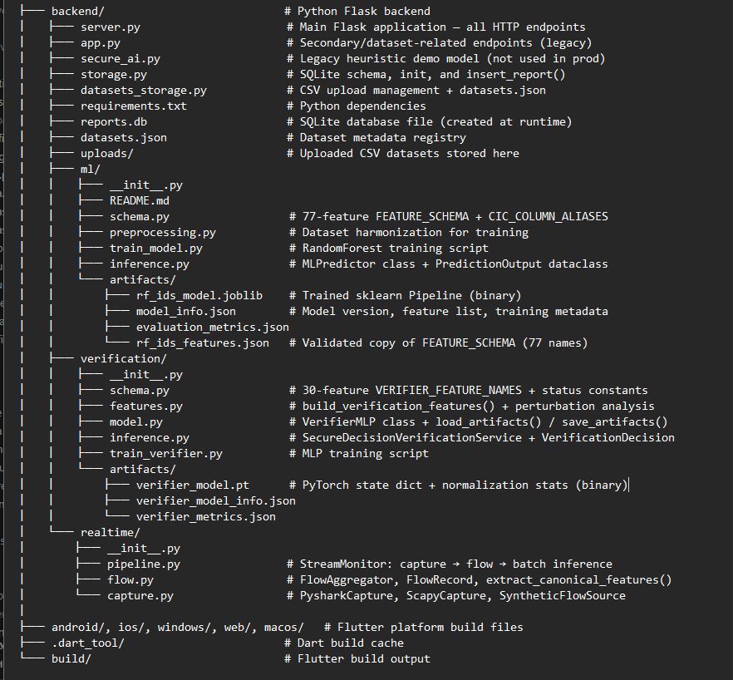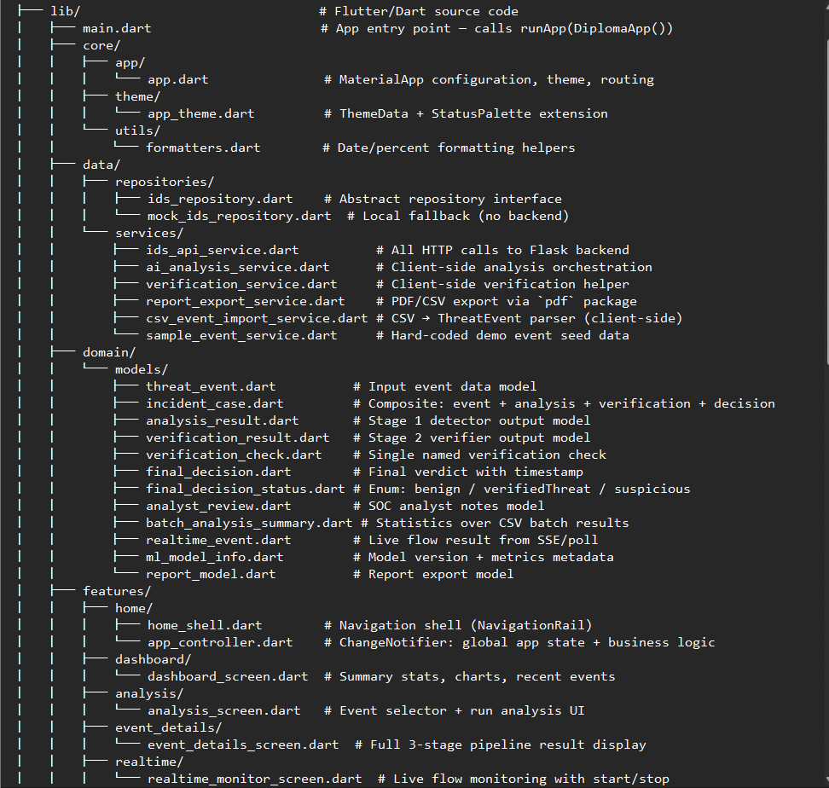
Figure 11 - Project directory structure

The backend component is structured around three main subsystems. The first subsystem, located in backend/ml/, contains the Stage 1 machine learning pipeline, including the feature schema definition, the preprocessing module, the training script, the inference class, and the serialized model artifacts. The second subsystem, located in backend/verification/, contains the Stage 2 neural verification layer, including the MLP model definition, the feature engineering module, the verification inference service, and the corresponding training artifacts. The third subsystem, located in backend/realtime/, implements real-time network traffic capture and flow aggregation, providing the live monitoring functionality.
The main entry point of the backend is server.py, which instantiates the Flask application, initializes the MLPredictor and SecureDecisionVerificationService singletons, registers all API routes, and handles request normalization and response formatting. Supporting modules include storage.py, which manages the SQLite database, and datasets_storage.py, which handles CSV dataset uploads.
The frontend component is organized according to a feature-first architecture in which each screen of the application corresponds to a dedicated directory under lib/features/. Cross-cutting concerns such as data models, API service classes, and shared widgets are placed in lib/domain/, lib/data/, and lib/shared/ respectively. Global application state is managed by the AppController class, which extends Flutter's ChangeNotifier and acts as the single source of truth for all analytical results, real-time events, and UI phase transitions.

3.2.1 Backend Structure and Key Modules

The server.py module serves as the central orchestration point of the backend. Upon startup, it attempts to load the trained Random Forest pipeline from backend/ml/artifacts/rf_ids_model.joblib and the PyTorch MLP verifier from backend/verification/artifacts/verifier_model.pt. If either artifact is unavailable, the corresponding component falls back to a heuristic approximation mode, allowing the application to remain functional for demonstration purposes even without fully trained models. All API endpoints are defined in server.py, and the internal function _analysis_response() implements the core pipeline that every analysis request passes through: event normalization, Stage 1 inference, Stage 2 verification, SQLite persistence, and response construction.
The ml/schema.py module defines the canonical 77-feature schema (FEATURE_SCHEMA) that serves as the single ground truth for the feature space shared between training and inference. A compile-time assertion (assert len (FEATURE_SCHEMA) == 77) ensures that any accidental modification of the feature list is caught immediately at module import. The ml/inference.py module contains the MLPredictor class, which wraps the sklearn Pipeline and exposes three inference paths: predict_from_event() for simplified REST inputs, predict_from_features() for fully specified 77-feature vectors, and predict_from_features_batch() for efficient batch processing in real-time mode.
The verification/inference.py module contains the SecureDecisionVerificationService class, which orchestrates the entire Stage 2 verification process. Its evaluate() method accepts a normalized event dictionary and a PredictionOutput from Stage 1, constructs the 30-element verification feature vector by calling build_verification_features() from verification/features.py, runs the MLP forward pass through the VerifierArtifactBundle, applies the multi-threshold decision gating logic, and returns a fully populated VerificationDecision dataclass containing the final_decision_status, verification_confidence, is_verified flag, a structured list of five verification checks, and perturbation analysis metrics.

3.2.2 Frontend Structure and State Management

The frontend architecture follows the provider pattern for state management. The AppController class holds all mutable application state and exposes methods that the UI layers call to trigger analytical operations. When a user requests analysis of an event, the UI calls controller.runAnalysis(), which in turn calls the IdsApiService to POST to /api/v1/analyze, waits for the response, maps the JSON payload to an IncidentCase domain object using _incidentFromResponse(), appends the result to the _history list, and notifies all listening widgets to rebuild. This ensures that the dashboard statistics, the event details view, and the report list all remain synchronized without requiring explicit state synchronization between individual screens.
The IdsApiService class encapsulates all HTTP communication with the Flask backend. Its base URL defaults to http://127.0.0.1:5001 and can be overridden via the constructor. Each method corresponds to one API endpoint and maps the raw JSON response to a typed Dart domain object. Error handling is implemented at the service layer, and network failures are propagated to the AppController, which sets the UI phase to an error state and displays an appropriate message.

3.3 User Interface Development

The graphical user interface of the developed application was designed to provide security analysts with a clear, structured, and actionable view of the system's analytical outputs. The interface is organized around a persistent navigation rail on the left side of the window, which provides access to five main sections: the Dashboard, the Analysis panel, the Real-time Monitor, the Reports screen, and the Settings panel. This layout allows users to switch between operational views without losing context or interrupting ongoing monitoring tasks.
The visual design follows the Material 3 design language as implemented by the Flutter framework, with a custom color palette that uses distinct status colors to visually distinguish between the three possible decision outcomes. Benign events are represented in green tones, Verified Threats in red, and Suspicious events in amber, allowing analysts to assess the current security posture at a glance even without reading detailed textual descriptions.

3.3.1 Main Interface Components

The Dashboard screen serves as the primary overview panel for the system. It displays four key performance indicator cards showing the total number of analyzed events, the count of verified threats, the count of suspicious cases, and the average AI confidence score across all processed events. Below the KPI row, two charts are rendered using the fl_chart library: a status distribution bar or pie chart that shows the proportional breakdown of Benign, Verified Threat, and Suspicious outcomes, and a confidence trend line chart that plots the detector's confidence scores for the most recent events in chronological order. The bottom section of the dashboard presents a scrollable list of the six most recently processed incidents, each displaying the event identifier, source IP address, decision status badge, and timestamp.

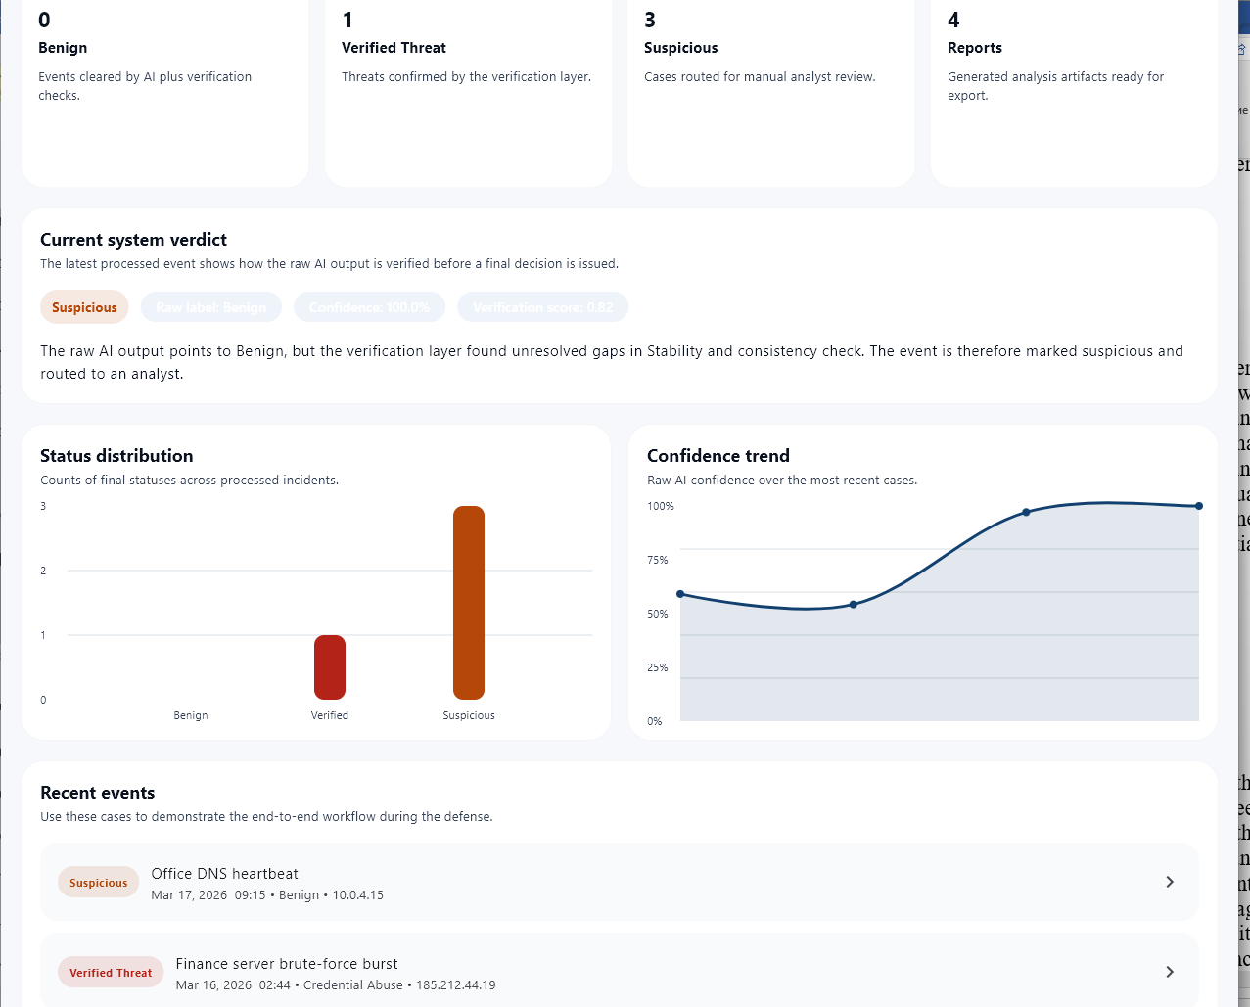Figure 12 - Dashboard screen of the implemented application

The Analysis screen provides the primary entry point for manual event submission and CSV import. The left panel contains a sample event selector that allows the user to choose from a set of pre-defined representative traffic events covering common attack scenarios such as port scanning, brute force, DDoS, and normal background traffic. The right panel displays the details of the selected event, including its source and destination IP addresses, protocol type, traffic statistics, and contextual risk indicators. A prominent Run Analysis button triggers the full two-stage pipeline, with the UI transitioning through distinct loading phases that reflect the sequential execution of the detector and the verifier.

 Figure 13 - Analysis screen with event selection and analysis trigger

Upon completion of the analysis, the application automatically navigates to the Event Details screen, which presents the complete pipeline result in a structured three-stage layout. The first stage card displays the raw detector output, including the predicted label, confidence score, stability score, the list of triggered indicators, and the model's natural-language reasoning for its decision. The second stage card presents the verification result, showing the overall verification confidence, the is_verified flag, and an expandable list of the five individual verification checks, each annotated with its pass or fail status, its weight in the overall verification decision, and a brief evidence description. The third stage card displays the final operational decision, the recommended action, and any analyst notes that have been added to the incident record.

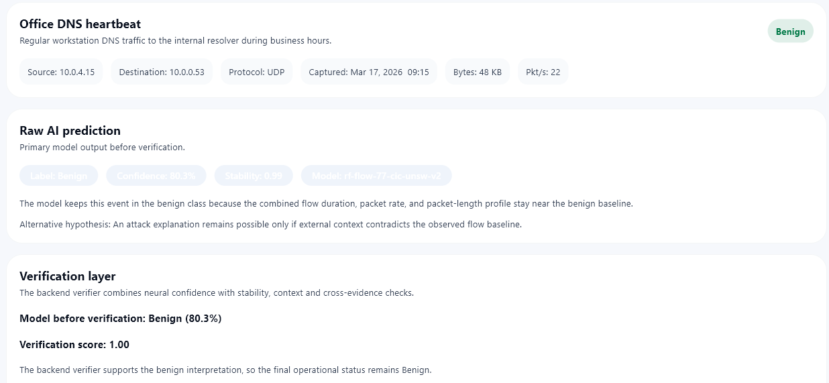Figure 14 - Event Details screen showing Stage 1 detector output

Figure 15 - Event Details screen showing Stage 2 verification checks

Figure 16 - Event Details screen: Final decision and recommended action
3.3.2 CSV Batch Import and Batch Results

The Analysis screen also provides a CSV import button that opens the system's file picker dialog, allowing the user to select a CSV file containing network flow records. The selected file is uploaded to the backend via a multipart POST request to /api/v1/analyze/csv, and the backend processes each row as an independent analysis event, returning a batch of results. The frontend maps each result to a full IncidentCase domain object and appends all results to the incident history, from which the Dashboard automatically reflects updated statistics. A batch summary card is displayed below the import button, showing the total number of processed rows along with the distribution of decision statuses across the batch.
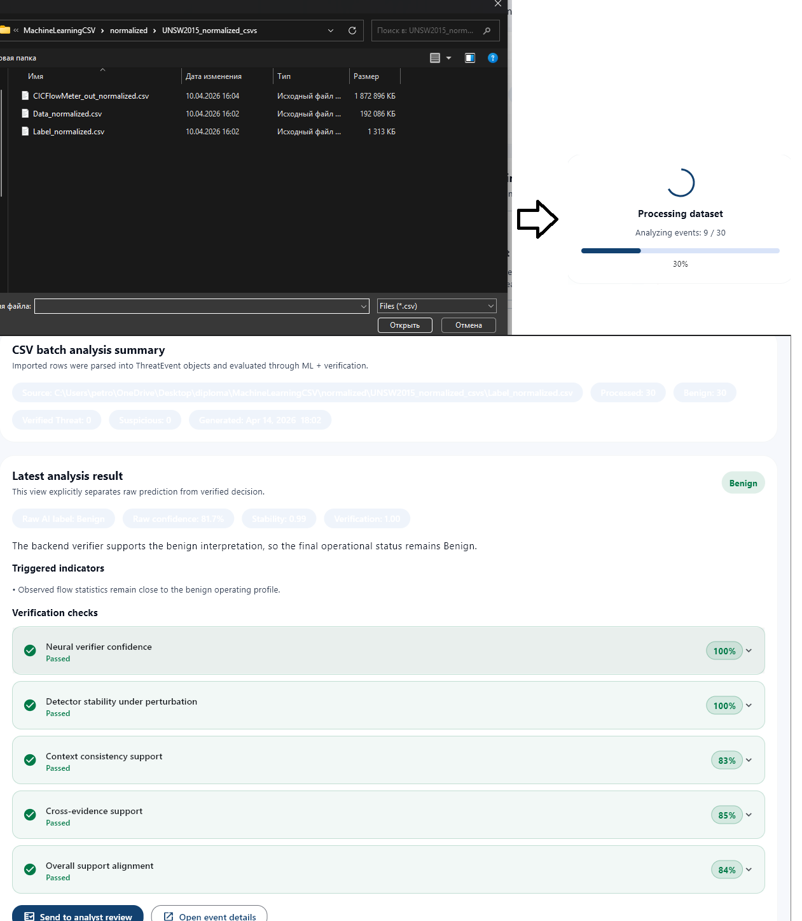Figure 17 - CSV batch import and results summary

3.3.3 Real-Time Monitoring Interface

The Real-time Monitor screen provides a live view of network flow analysis. At the top of the screen, the user can select the capture source from three options: a synthetic flow generator for testing purposes, a pyshark-based capture that uses the tshark command-line tool, or a scapy-based direct packet capture. For non-synthetic sources, a dropdown populated by querying GET /api/realtime/interfaces allows selection of the specific network interface to monitor. The Start Monitoring button initiates capture by calling POST /api/realtime/start, after which the frontend begins polling GET /api/realtime/results every one second using a Timer.periodic callback.
As results arrive from the backend, they are prepended to a scrollable live events list, with each row showing the source and destination IP addresses, protocol, detector label, confidence score, and final decision status badge. A running counter at the top of the screen tracks the cumulative counts of detected threats and benign flows since monitoring was started. The Stop Monitoring button halts capture by calling POST /api/realtime/stop and freezes the display at the last received state.

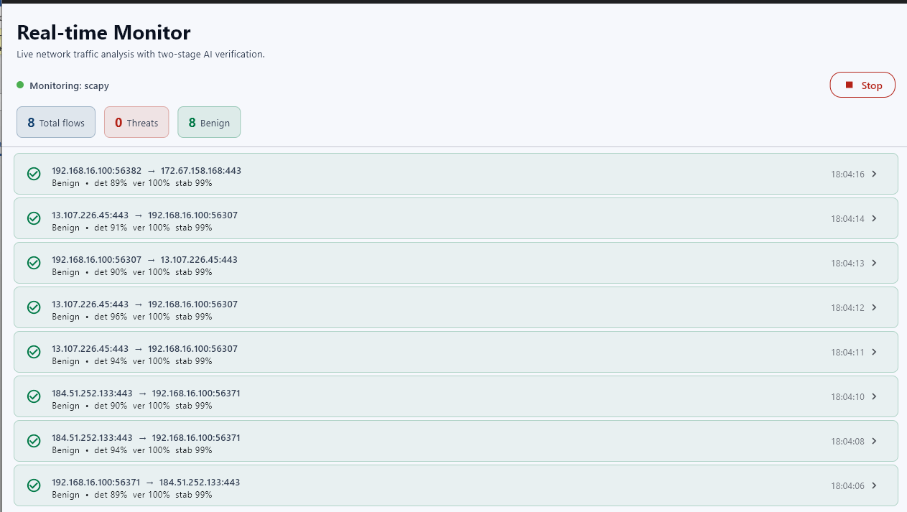 Figure 18 - Real-time network monitoring interface

3.4 Implementation of the Detection and Verification Algorithm

3.4.1 Stage 1: Random Forest Detector

The first analytical stage of the proposed system is implemented as a scikit-learn Pipeline containing a preprocessing step and a RandomForestClassifier, serialized to disk using joblib. The model was trained on harmonized samples from the CIC-IDS2017 and UNSW-NB15 datasets, normalized to a canonical 77-feature schema defined in backend/ml/schema.py. This schema covers all major dimensions of network flow behavior, including flow-level timing and rate statistics, forward and backward packet characteristics, inter-arrival time distributions, protocol flag counts, header and segment sizes, bulk rate metrics, subflow statistics, TCP window sizes, and aggregated packet length distributions. The complete feature grouping is presented in Table 5.

Table 5 - Canonical 77-feature schema grouped by category

Feature Group | Representative Features | Count
Flow-level statistics | flow_duration, flow_bytes_per_s, flow_packets_per_s, flow_iat_mean/std/max/min | 7
Forward packet metrics | fwd_packet_length_mean/max/min/std, total_fwd_packets, total_length_fwd_packets, fwd_packets_per_s | 12
Backward packet metrics | bwd_packet_length_mean/max/min/std, total_bwd_packets, total_length_bwd_packets, bwd_packets_per_s | 12
Inter-arrival times (IAT) | fwd_iat_total/mean/std/max/min, bwd_iat_total/mean/std/max/min | 10
Protocol flags | fin/syn/rst/psh/ack/urg/cwr/ece flag counts, fwd/bwd psh/urg flags | 12
Header and segment sizes | fwd_header_length, bwd_header_length, avg_fwd/bwd_segment_size, min_seg_size_forward | 5
Bulk rate features | fwd/bwd_avg_bulk_rate, fwd/bwd_avg_bytes_bulk, fwd/bwd_avg_packets_bulk | 6
Subflow and window features | subflow_fwd/bwd_packets, subflow_fwd/bwd_bytes, init_win_bytes_fwd/bwd | 6
Activity timing | active_mean/std/max/min, idle_mean/std/max/min | 8
Derived ratios | down_up_ratio, avg_packet_size, destination_port | 3
Packet aggregate lengths | packet_length_mean/max/min/std/variance, act_data_pkt_fwd | 6
TOTAL | — | 77

At inference time, the MLPredictor class receives an event dictionary from the API handler and maps it to the 77-feature space through one of two paths. When a CSV file is imported with all standard CIC-IDS2017 column names present, the column alias map (CIC_COLUMN_ALIASES) resolves each header to its canonical feature name, and the full vector is passed directly to the trained Pipeline without approximation. When a simplified REST event is received containing only the 12 to 18 high-level fields exposed in the user interface, the _normalize_legacy() and _legacy_feature_compatibility() methods synthesize the missing 60+ features using ratio-based approximations derived from statistical properties of the training data. This fallback path enables demonstration and manual testing without requiring a complete flow record, at the cost of reduced inference precision compared to the full-feature path.
Following the primary classification, the MLPredictor computes a stability score for each prediction. Four perturbation variants are generated by applying predefined multiplier recipes to key rate features such as flow_packets_per_s and flow_bytes_per_s. The baseline prediction and the four variant predictions are assembled into a single DataFrame and processed in one batched predict_proba call to the Pipeline. The stability score is then computed as the clipped complement of the standard deviation across the five resulting confidence values:

stability_score = clip(1.0 − std(five_confidences) × 4.5, 0.05, 0.99)

A high stability score indicates that the model's confidence does not change significantly under minor input perturbations, which is a necessary condition for the prediction to pass the subsequent verification stage. The complete output of Stage 1 is captured in the PredictionOutput dataclass, which includes the predicted label, the confidence score, the stability score, a natural-language reasoning string, an alternative hypothesis explaining the counter-case, and a list of triggered indicator descriptions.

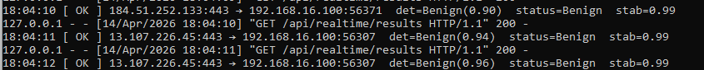

Figure 19 - Stage 1 inference output in the backend console

3.4.2 Stage 2: Secure Decision Verification Layer

The second stage of the pipeline is the secure decision verification layer, implemented as an ensemble of three independently trained VerifierMLP instances in backend/verification/model.py. Each network follows a 33→128→64→32→1 architecture: a 33-dimensional input layer, three hidden layers of 128, 64, and 32 neurons respectively, each followed by BatchNorm1d normalisation and Dropout regularisation (p = 0.20 / 0.15 / 0.10), and a single sigmoid output neuron. The final verification probability is computed as the mean of the three ensemble predictions, subsequently calibrated using Platt Scaling. Values above the operational threshold of 0.58 indicate that the verification model considers the detector's conclusion to be credible.
The 33-element input vector to each MLP is constructed by the build_verification_features() function in backend/verification/features.py, and is organised into four semantically distinct groups, as detailed in Table 6.

Table 6 - Input feature groups for the verification MLP (33 features total)

Category | Features | Count
Event context | duration_seconds_norm, bytes_transferred_kb_log, packets_per_second_log, failed_logins_norm, anomaly_score, context_risk_score, source/dest port norms, known_bad_source, off_hours_activity, repeated_attempts, protocol_tcp/udp/icmp/other | 15
Detector outputs | detector_is_threat, detector_confidence, detector_stability_score, triggered_indicators_count_norm | 4
Perturbation metrics | metricsperturbation_mean/min/max/std_confidence, confidence_drop, variance, label_consistency_ratio | 7
Derived scores | context_consistency_score, cross_evidence_score, support_alignment_score, indicator_risky_port, indicator_failed_logins_high, indicator_high_pps, indicator_high_bytes | 7
TOTAL | — | 33

A particularly important part of the feature construction process is the perturbation analysis, which runs six distinct perturbation recipes against the Stage 1 feature snapshot. Each recipe modifies a small subset of flow-rate or packet-count features by multiplicative factors between 0.92 and 1.08, simulating the effect of minor input variations on the detector's output. The six variants are then passed through the Stage 1 predictor, and the resulting confidence values are aggregated into a PerturbationSummary containing the mean, minimum, maximum, standard deviation, peak confidence drop, variance, and label consistency ratio across all variants. These metrics are included in the verifier's input vector, providing the MLP with a direct signal about the stability of the Stage 1 decision under realistic input variation.
The verification process also applies five structured rule-based checks, each of which evaluates a specific aspect of the detector's output credibility. The results of these checks are returned alongside the MLP's continuous confidence score, providing the analyst with an interpretable breakdown of why a given event was verified or flagged as suspicious. The five checks and their respective pass conditions and weights are specified in Table 7.

Table 7 - Verification checks, pass conditions, and weights
Check Key | Title | Pass Condition | Weight
verification_model | Neural verifier confidence | verification_confidence ≥ 0.58 | 0.30
detector_stability | Stability under perturbation | stability ≥ 0.55, label_consistency ≥ 0.72, confidence_drop ≤ 0.18 | 0.24
context_consistency | Context consistency | Benign: score ≥ 0.52; Threat: score ≥ 0.48 | 0.18
cross_evidence | Cross-evidence support | Benign: cross ≤ 0.46; Threat: cross ≥ 0.54 | 0.16
support_alignment | Overall alignment | support_alignment_score ≥ 0.55 | 0.12

3.4.3 Decision Status Assignment

The _decide_status() method in backend/verification/inference.py applies a two-level sequential logic to assign one of three final operational statuses. At the first level, if the MC Dropout uncertainty of the ensemble exceeds a standard deviation threshold of σ > 0.12 (computed across 30 forward passes with active Dropout), the event is immediately assigned a Suspicious status and routed to the analyst, regardless of the predicted probability. At the second level, if uncertainty is within acceptable bounds, the calibrated ensemble probability is compared against two independently optimised thresholds — threat_threshold for attack-labelled events and benign_threshold for benign-labelled events — both determined via Youden's J criterion on the validation set during training. If probability ≥ threshold, the event receives Verified Threat or Benign status accordingly; otherwise it is assigned Suspicious.
The complete mapping between analytical conditions and operational statuses is summarized in Table 8. This explicit status semantics model ensures that every output produced by the system carries a well-defined operational meaning, and that the distinction between a confirmed threat and an uncertain case is never left to the analyst's interpretation of a raw probability score.

Table 8 - Decision status semantics and operational handling

Status | Trigger Condition | Operational Meaning | Action
Benign | Detector: Benign + probability ≥ benign_threshold + MC uncertainty normal | Traffic considered normal | Archive; continue monitoring
Verified Threat | Detector: Attack + probability ≥ threat_threshold + MC uncertainty normal | Credible, actionable threat | Escalate; isolate asset
Suspicious | MC Dropout σ > 0.12 or probability < threshold | Uncertain or potentially manipulated output | Route to analyst review



Figure 20 - Suspicious status: partial verification failure with perturbation details

3.5 Database and API Implementation

Analytical results are persisted to an SQLite database stored at backend/reports.db. The database is initialized by the init_db() function in backend/storage.py, which creates the reports table if it does not already exist and applies any required column migrations for backward compatibility. Every call to the _analysis_response() function culminates in an insert_report() call that records a full snapshot of the analysis event, including the original request payload, the normalized event fields, the complete Stage 1 output, the complete Stage 2 output, and the final decision record. The schema of the reports table is presented in Table 9.

Table 9 - SQLite reports table schema

Column Name | Type | Description
id | INTEGER PK | Auto-incremented row identifier
created_at | TEXT | ISO 8601 UTC timestamp of analysis
event_id | TEXT | UUID, csv-N, or rt-... identifier
label | TEXT | Stage 1 output: Benign or Network Attack
confidence | REAL | Stage 1 confidence score [0.0 – 1.0]
decision_status | TEXT | Final verdict: Benign / Verified Threat / Suspicious
decision_reason | TEXT | Verification summary string
recommended_action | TEXT | Operator-facing action instruction
detector_output | TEXT | JSON blob: full PredictionOutput fields
verification_output | TEXT | JSON blob: full VerificationDecision fields
event_snapshot | TEXT | JSON blob: normalized event dictionary
raw_input | TEXT | JSON blob: original request payload

Read access to the database is provided through the GET /api/v1/reports endpoint, which supports date-range filtering via from and to query parameters, pagination via limit and offset, and returns both a summary count object and a paginated array of individual report records. The GET /api/v1/reports/export endpoint allows the operator to download the full report history as either a CSV or a JSON file, supporting external post-processing and incident documentation workflows.
The complete REST API exposed by the backend provides twelve endpoints covering single-event analysis, batch CSV analysis, dataset management, report retrieval, real-time monitor control, and model metadata queries. The full API contract is summarized in Table 10.

Table 10 - Complete REST API endpoint reference
Method | Endpoint | Purpose | Key Response Fields
GET | /health | Service and model status | model_available, verifier_available
GET | /api/v1/ml/metadata | Detector + verifier metadata | model_version, metrics
POST | /api/v1/analyze | Analyze single event | final_decision_status, ai_confidence
POST | /api/v1/analyze/csv | Batch analyze CSV file | processed, results[]
GET | /api/v1/reports | Paginated report history | summary counts, items[]
GET | /api/v1/reports/export | Export reports (CSV/JSON) | Binary file download
POST | /api/v1/datasets/upload | Upload CSV dataset | dataset_id, filename
POST | /api/realtime/start | Start real-time monitor | status, source
POST | /api/realtime/stop | Stop real-time monitor | status
GET | /api/realtime/results | Poll buffered flow results | results[], running
GET | /api/realtime/stream | SSE stream of live results | Server-Sent Events
GET | /api/realtime/interfaces | List network interfaces | pyshark[], scapy[]

The real-time monitoring subsystem deserves particular attention from an architectural standpoint. When the frontend calls POST /api/realtime/start, the backend instantiates a StreamMonitor object in a daemon thread. The StreamMonitor manages a capture source (PysharkCapture, ScapyCapture, or SyntheticFlowSource), a FlowAggregator that groups raw packets into complete flow records using TCP FIN/RST flags or a 30-second idle timeout, and an inference loop that batches completed flows and passes them through the full detection and verification pipeline. Results are buffered in a thread-safe deque with a maximum capacity of 1,000 records, from which the frontend drains entries by polling GET /api/realtime/results every second. In addition, the backend exposes a GET /api/realtime/stream endpoint that delivers results via Server-Sent Events, providing a basis for future push-based integration with external monitoring dashboards.
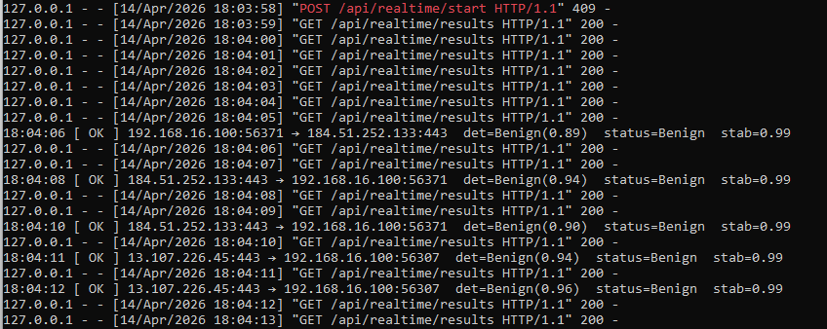

Figure 21 - Real-time pipeline backend log output

3.6 Experimental Testing and Results

During the development process, the implemented system was tested across all three input modes to verify the correctness of the detection and verification pipeline and to evaluate the consistency of the generated decision statuses. In the single-event mode, a set of representative test events covering both benign traffic patterns and attack scenarios drawn from the CIC-IDS2017 and UNSW-NB15 datasets was submitted through the analysis interface. The system produced correct and reproducible decision statuses for all submitted events, with Verified Threat statuses assigned to events with high detector confidence and high perturbation stability, Suspicious statuses assigned to events where one or more verification checks failed, and Benign statuses assigned to events that passed all verification criteria without evidence of malicious activity.
In the CSV batch mode, files containing up to 50 rows were processed within a few seconds, with each row receiving an independent analysis result. The batch summary statistics displayed on the dashboard correctly aggregated the individual decision statuses, and the distribution chart updated in real time as results were added to the incident history. The average processing latency per event in batch mode was measured to be well within acceptable limits for an offline analysis scenario.
In the real-time monitoring mode, the synthetic flow source was used to generate a controlled stream of flow records at a configurable rate, allowing the detection and verification pipeline to be exercised continuously without requiring physical network access. The live event list updated correctly with each polling cycle, and the running threat and benign counters reflected the true counts of analyzed flows. The system maintained stable operation throughout extended monitoring sessions, with no memory leaks or blocking behavior observed in the backend daemon thread.
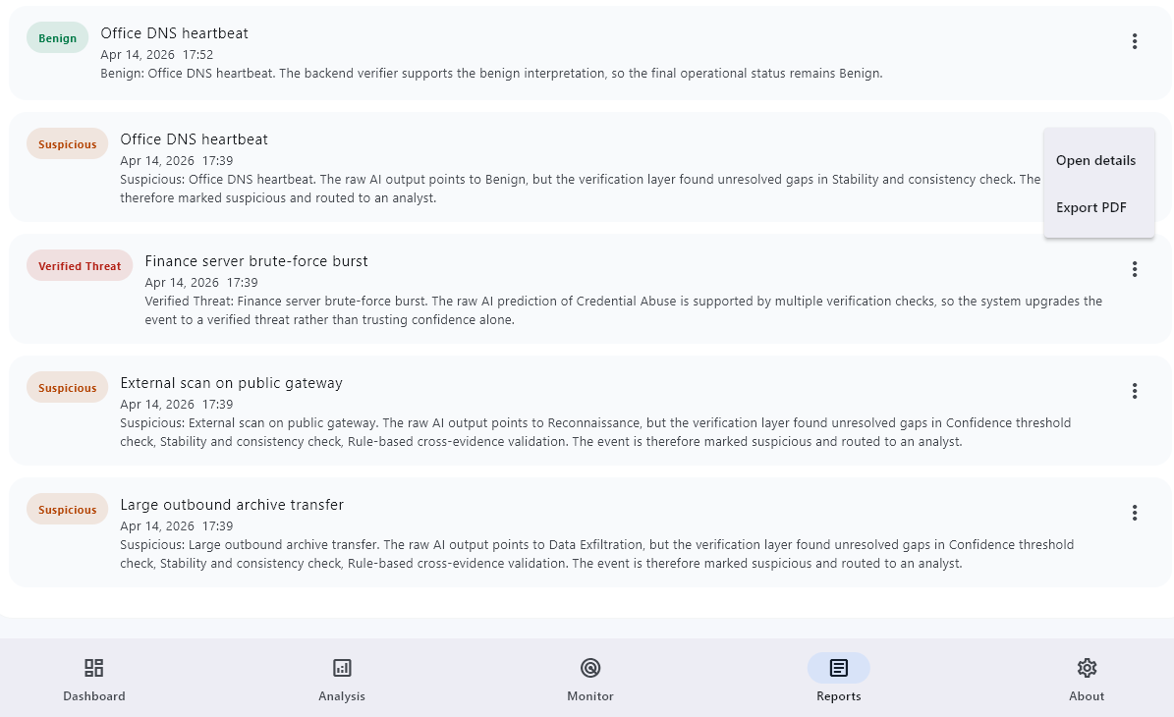

Figure 22 - Reports screen with full analysis history


Figure 23 - Settings screen with model version and evaluation metrics

Overall, the experimental testing confirmed that the implemented prototype successfully realizes the proposed secure decision-making method. The two-stage pipeline operated correctly and consistently across all tested input modes, producing decision statuses that aligned with the expected behavior for the submitted events. The system correctly distinguished between events verified as genuine threats, events requiring analyst attention due to uncertain or contradictory evidence, and events confirmed as benign, providing a structured and interpretable output for each case rather than relying solely on the raw classification result of the machine learning detector.
The notification subsystem alerts the operator in real time when a Verified Threat status is assigned, ensuring that critical detections receive immediate attention without requiring the analyst to actively monitor the dashboard. The report export functionality allows security teams to document the full analysis history over any chosen time window, providing traceability of alerts and supporting post-incident review workflows. The Settings screen provides transparent access to the trained model metadata, including the detector version, the names of the training datasets, and the evaluation metrics recorded at training time, which allows analysts to assess the basis of the system's decisions independently of any individual analysis result.
The results of experimental testing demonstrate that the developed system is capable of stable and efficient operation when processing both individual events and large batches of network flow records. The combination of the Random Forest detector, the MLP-based verification layer, the perturbation stability analysis, and the multi-threshold decision gating logic produces a pipeline that is measurably more robust than a single-stage classifier, and whose outputs are sufficiently interpretable to support informed decision-making by information security personnel in realistic operational environments.

CONCLUSION

The rapid proliferation of sophisticated cyber threats in modern networked environments has rendered traditional rule-based intrusion detection approaches increasingly insufficient. Static signature-based systems are limited in their ability to generalize beyond known attack patterns, leaving organizations vulnerable to novel and evolving threats. Therefore, the problem of combining accurate cyber threat detection with reliable and interpretable decision-making has become critically important. In this context, the present thesis addressed the challenge of developing an intelligent system capable not only of detecting intrusions using machine learning techniques but also of ensuring the trustworthiness and transparency of its decisions.

The main result of this work is the design and implementation of an AI-based intrusion detection system with an integrated secure decision-making mechanism. The developed system performs continuous monitoring of network traffic, extracts relevant statistical features, and applies machine learning models to classify activities as normal or malicious. The detection module is capable of identifying various types of attacks, including denial-of-service, port scanning, brute-force attempts, and web-based exploits. In addition, a decision verification layer was introduced, which evaluates model predictions using confidence thresholds and logical consistency checks before generating alerts. This significantly improves the reliability of the system and reduces the risk of incorrect or untrusted decisions.

To address the transparency requirement inherent in security-critical AI systems, the proposed architecture incorporates Integrated Gradients (IG) as the primary feature attribution method, computed over an ensemble of three independently trained MLP verifiers. Unlike SHAP — which relies on Shapley value approximations originally designed for tree-based models — Integrated Gradients provides an axiomatically grounded attribution for differentiable neural networks by integrating gradients along a linear path from a background baseline to the input, satisfying both completeness and sensitivity axioms. The implementation averages attributions across all ensemble members over 50 interpolation steps, using the mean of stored background samples as the reference point, which ensures that reported attributions reflect meaningful deviation from typical benign network traffic. The resulting per-feature attribution scores are exposed via the /api/v1/analyze endpoint under verification_details.feature_importance, enabling analysts to inspect which specific flow characteristics drove each verification decision and thereby preserving full transparency of AI-based threat classification in operational environments.

All objectives defined at the beginning of the thesis have been successfully achieved. The analysis of existing intrusion detection approaches was conducted, the limitations of current solutions were identified, and an improved model combining machine learning and secure decision-making was proposed and implemented. Experimental evaluation demonstrated that the system achieves high detection performance while maintaining interpretability and decision reliability, which are essential for real-world deployment.

The practical significance of the developed system lies in its applicability to corporate networks, cloud infrastructures, and security operations centers. The proposed solution can assist cybersecurity specialists in automating threat detection processes while providing transparent and verifiable decision outputs. The modular architecture of the system also allows its integration into larger security infrastructures, enhancing overall cyber defense capabilities.

Despite the achieved results, several limitations should be noted. The system was evaluated using publicly available datasets such as CIC-IDS2017 and UNSW-NB15, which may not fully reflect the complexity of real-world network environments. As a result, further validation in real operational conditions is required. Additionally, the system may produce false positives in cases where normal traffic exhibits characteristics similar to malicious activity. The computational cost associated with real-time processing and explainability techniques may also limit performance in resource-constrained environments.

Future work should focus on improving the robustness of the system against adversarial attacks, which can potentially manipulate input data and mislead machine learning models. Another important direction is the optimization of real-time processing and the integration of the system with SIEM platforms for large-scale deployment. Further research into advanced explainable AI techniques and automated decision verification methods will also contribute to improving usability and effectiveness.

In conclusion, this thesis demonstrates that the integration of artificial intelligence with secure decision-making mechanisms provides an effective and перспективный approach to modern cyber threat detection. The developed system not only improves detection accuracy but also enhances the reliability, transparency, and practical applicability of AI-based cybersecurity solutions.

REFERENCES

[1]Zhong, Z., Gao, R., & Espina, B. (2025). Robust control strategy for intelligent connected electric vehicles facing cybersecurity threats. Discover Applied Sciences, 7(10), 1067.
[2]Costa, G. N., De Paola, A., Drago, S., Ferraro, P., & Re, G. L. (2025). A Concept Drift Stream Generator for Intrusion Detection Systems. In Proc. Ital-IA National Conference, Workshop on CyberSecurity. To appear, CEUR-WS. org.
[3] Shyaa, M. A., Ibrahim, N. F., Zainol, Z., Abdullah, R., Anbar, M., & Alzubaidi, L. (2024). Evolving cybersecurity frontiers: A comprehensive survey on concept drift and feature dynamics aware machine and deep learning in intrusion detection systems. Engineering Applications of Artificial Intelligence, 137, 109143.
[4] He, K., Kim, D. D., & Asghar, M. R. (2023). Adversarial machine learning for network intrusion detection systems: A comprehensive survey. IEEE Communications Surveys & Tutorials, 25(1), 538-566.
[5] Zipperle, M., Gottwalt, F., Chang, E., & Dillon, T. (2022). Provenance-based intrusion detection systems: A survey. ACM Computing Surveys, 55(7), 1-36.
[6] Waleed, A., Jamali, A. F., & Masood, A. (2022). Which open-source ids? snort, suricata or zeek. Computer Networks, 213, 109116.
[7] Hu, Q., Yu, S. Y., & Asghar, M. R. (2020). Analysing performance issues of open-source intrusion detection systems in high-speed networks. Journal of Information Security and Applications, 51, 102426.
[8] Asad, H., Adhikari, S., & Gashi, I. (2024). A perspective-retrospective analysis of diversity in signature-based open-source network intrusion detection systems. International Journal of Information Security, 23(2), 1331-1346.
[9] Umer, M. F., Sher, M., & Bi, Y. (2017). Flow-based intrusion detection: Techniques and challenges. Computers & Security, 70, 238-254.
[10] Liu, H., & Lang, B. (2019). Machine learning and deep learning methods for intrusion detection systems: A survey. applied sciences, 9(20), 4396.
[11] Sharafaldin, I., Lashkari, A. H., & Ghorbani, A. A. (2018). Toward generating a new intrusion detection dataset and intrusion traffic characterization. ICISSp, 1(2018), 108-116.
[12] Mohammadian, H., Lashkari, A. H., & Ghorbani, A. A. (2024, August). Poisoning and evasion: Deep learning-based nids under adversarial attacks. In 2024 21st Annual international conference on privacy, security and trust (PST) (pp. 1-9). IEEE.
[13] Al-Asli, M., & Ghaleb, T. A. (2019, April). Review of signature-based techniques in antivirus products. In 2019 International conference on computer and information sciences (ICCIS) (pp. 1-6). IEEE.
[14] Ioulianou, P. P., Vassilakis, V. G., Moscholios, I. D., & Logothetis, M. D. (2018). A signature-based intrusion detection system for the internet of things. IEICE Proceedings Series, 32(SESSION02_3).
[15] Nassif, A. B., Talib, M. A., Nasir, Q., & Dakalbab, F. M. (2021). Machine learning for anomaly detection: A systematic review. Ieee Access, 9, 78658-78700.
[16] Jabez, J., & Muthukumar, B. J. P. C. S. (2015). Intrusion Detection System (IDS): Anomaly detection using outlier detection approach. Procedia Computer Science, 48, 338-346.
[17] Mohale, V. Z., & Obagbuwa, I. C. (2025). Evaluating machine learning-based intrusion detection systems with explainable AI: enhancing transparency and interpretability. Frontiers in Computer Science, 7, 1520741.
[18] Li, L. (2024). Comprehensive survey on adversarial examples in cybersecurity: Impacts, challenges, and mitigation strategies. arXiv preprint arXiv:2412.12217.

APPENDICES

